**Achievements between 12/1/10 and 3/14/11**

1. Screenings are more complete with fewer missed items as I have learned to recognize required items
2. Initial apps were backed up into October and were fully caught up in mid January for screenings resulting in more initial providers being certified
3. Increased use and proficiency with MMIS
4. Better personal tracking system for screenings missing items and quicker turnaround on matching incoming items with packets
5. More detailed training of MASST in files as team lead
6. Increased participation in task committee and additional regular meetings
7. Update CIR training regularly
8. Decreased turnaround time on CPR waivers to meet ACS/provider needs to get PCAs enrolled
9. Attended introduction to supervisor training to increase skills in team leadership with MASST & DVR
10. Suggested meetings be recorded and then suggested software to take voice recordings and convert to text.
11. Voice recorder and software will be installed on my computer and I am learning how to do this to make meeting minutes easier to produce.
12. Assisted in facilitating the replacement of large copier when equipment failed… still in progress
13. Setup statistic tracking for CPR waivers based on city, agency etc now in DS3
14. Suggest that SDS do a provider survey via Survey monkey modeling the required surveys that providers have to send to us during recertification.. need to do revisions based on feedback. Draft questions for the survey
15. Research who to talk to and get the survey online
16. Mail merge labels and discover that Word skips one entry per page resulting in the need to adjust mail out lists to ensure that all letters/labels are created
17. Suggested HAB home tracker be done using DS3 vs setting up another Excel spreadsheet tracker
18. Keep CIR training up to date in DS3
19. Keep CPR waiver info in DS3 and up to date (75 waivers from start of calendar year)
20. Trained Nancy in file creation/maintenance increased computer proficiency a little
21. Will be training both MASST to do Sharepoint Archiving this week

Care Coordination Agencies and Care Coordinators List

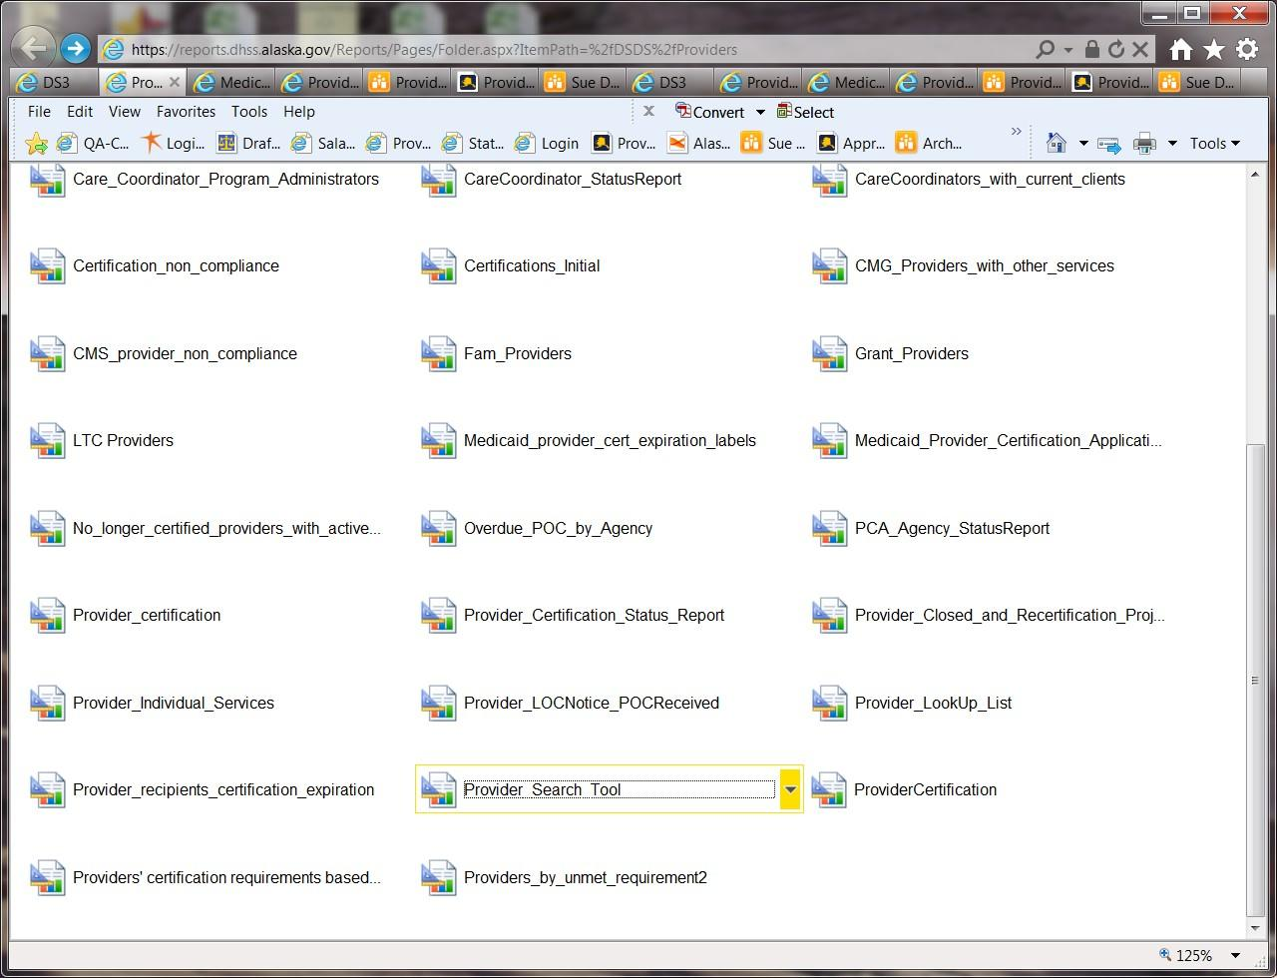

* Reports Manager > Provider_Search_Tool report

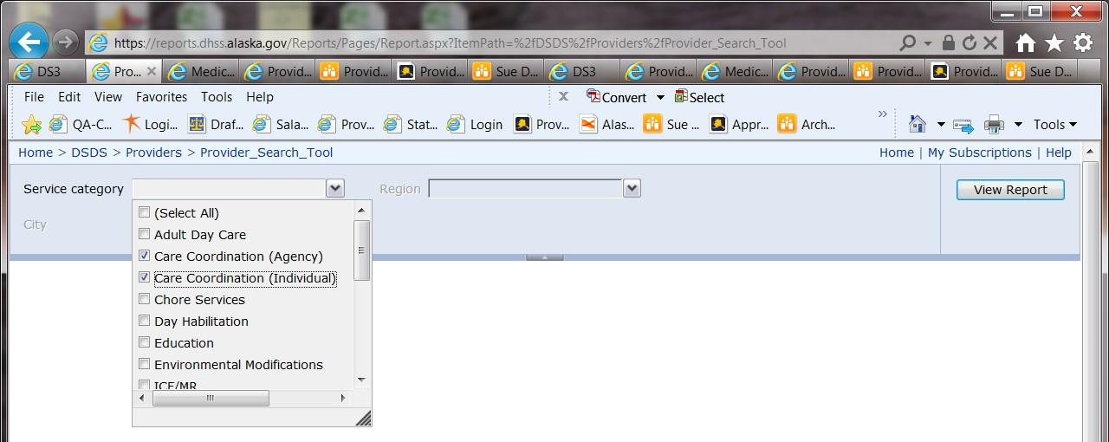

Care Coordinator List

* Care Coordination (Agency)
* Care Coordination (Individual)

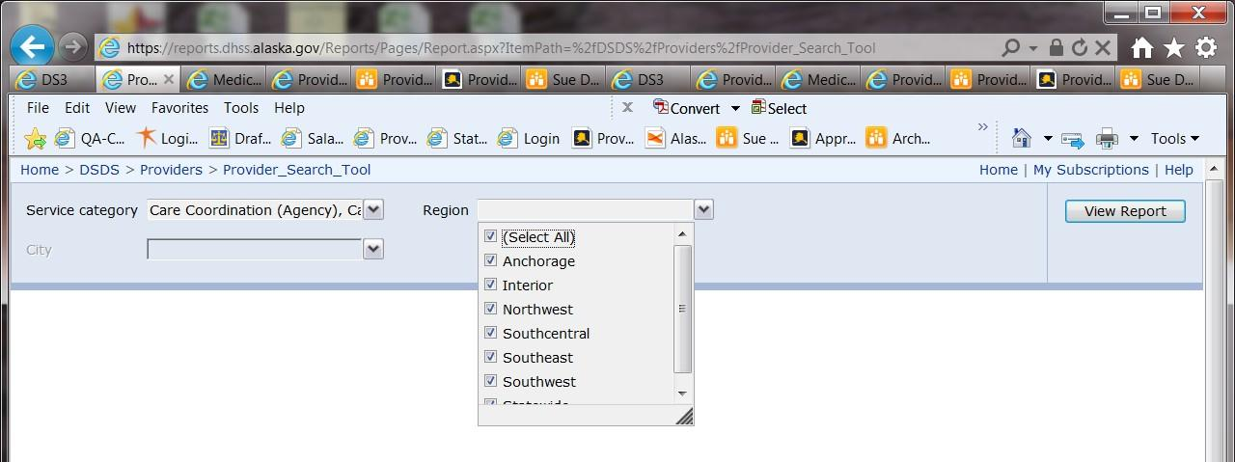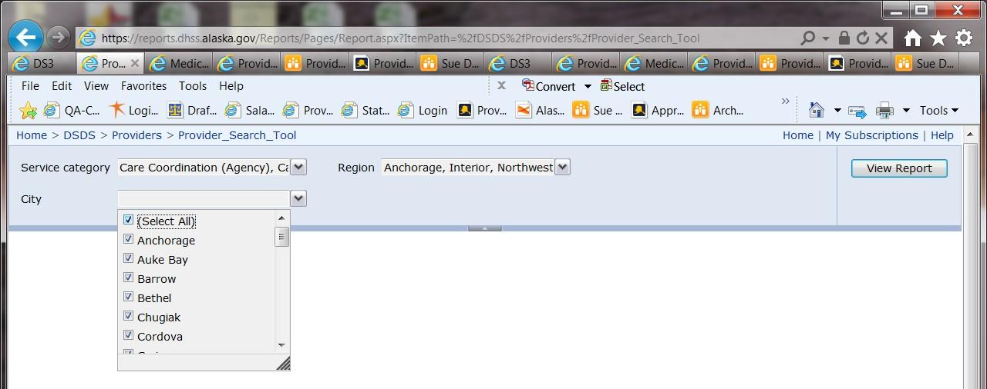

* Select all regions
* Select all cities
* The exception is if the report is being generated for a special request for a specific area then the list can be narrowed down by region or city per the request. (rare but does happen)

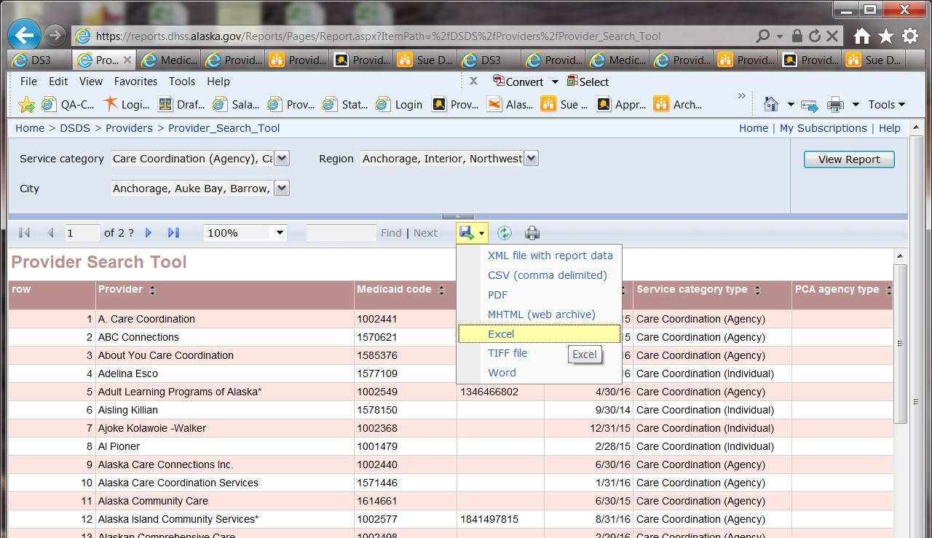

* Report is displayed
* Export to Excel

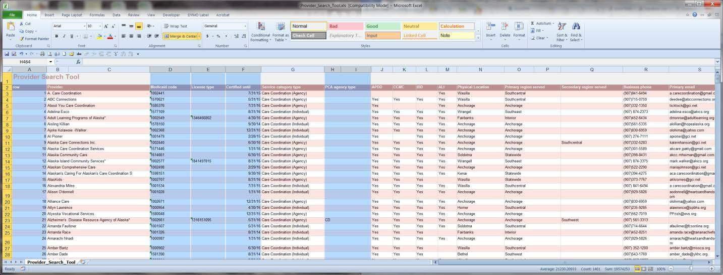

* Select Row, Medicaid Code, License Type, Certified Until and PCA Agency Type and delete the columns as they are not needed for this report and are for reference for other reports.

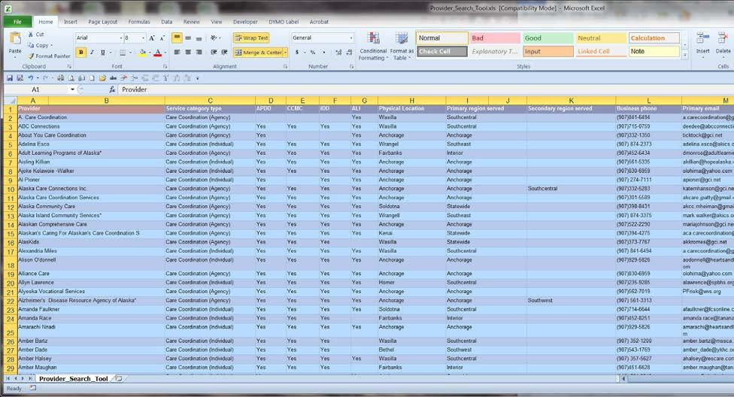

* Hold both Ctrl-Shift and the → key to selectthe columns needed and still holding Ctrl & Shift use the to select all the rows.

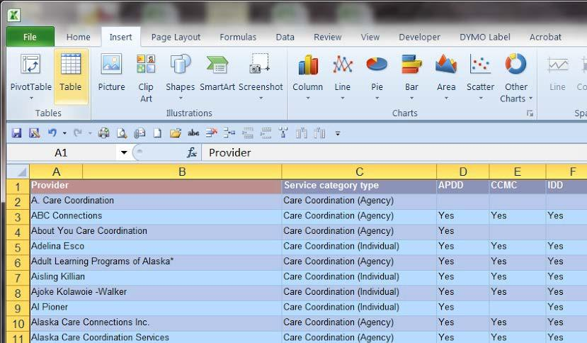

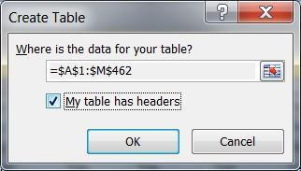

* Check the My Table has headers box

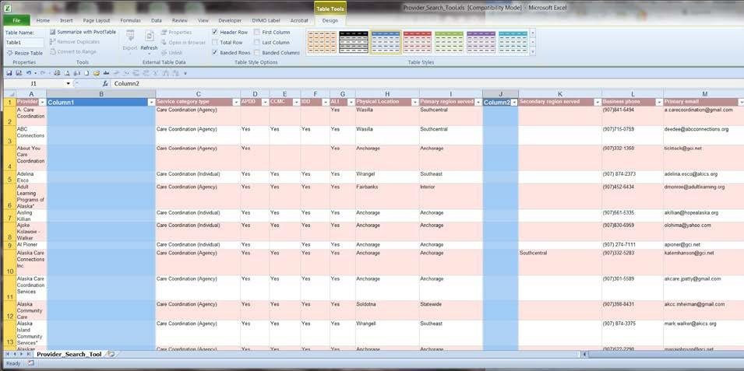

* Delete extra columns
* Adjust remaining columns to fit the text horizontally and vertically

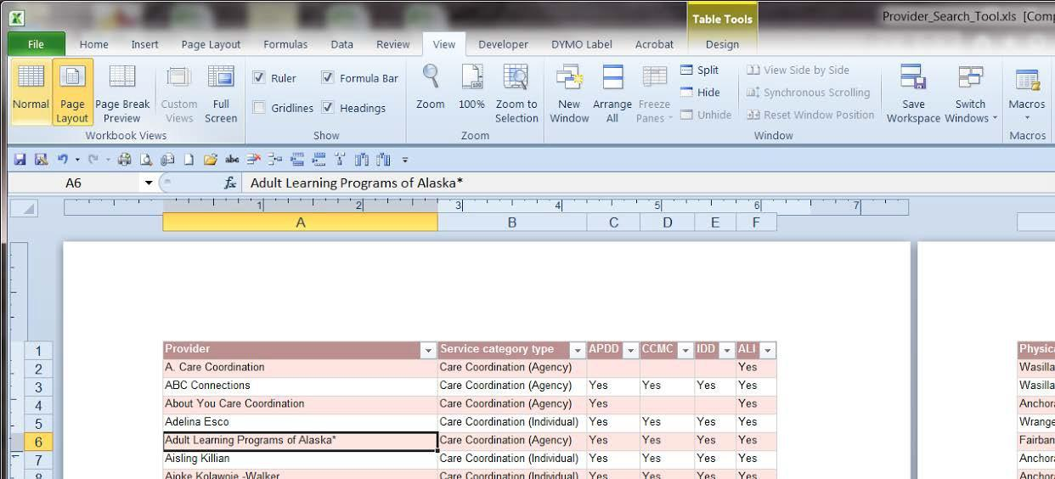

* Go to View → Page Layout → Landscape

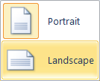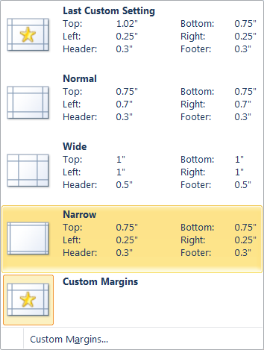

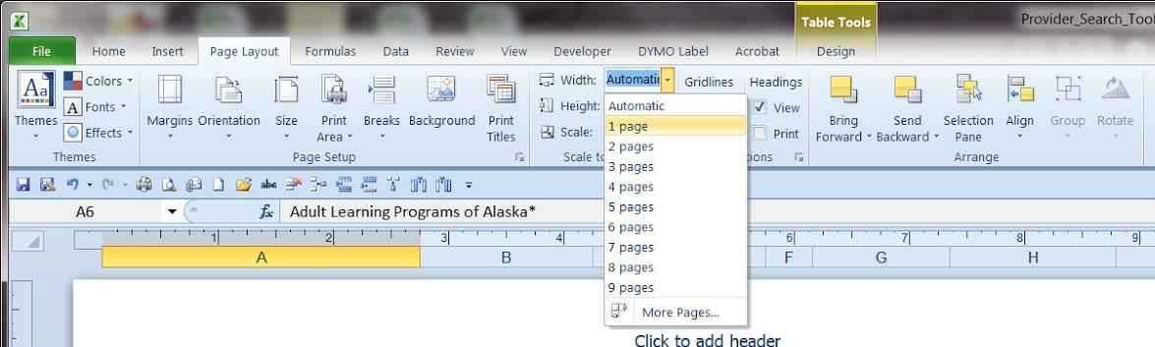

* Adjust page width from Automatic to 1 page

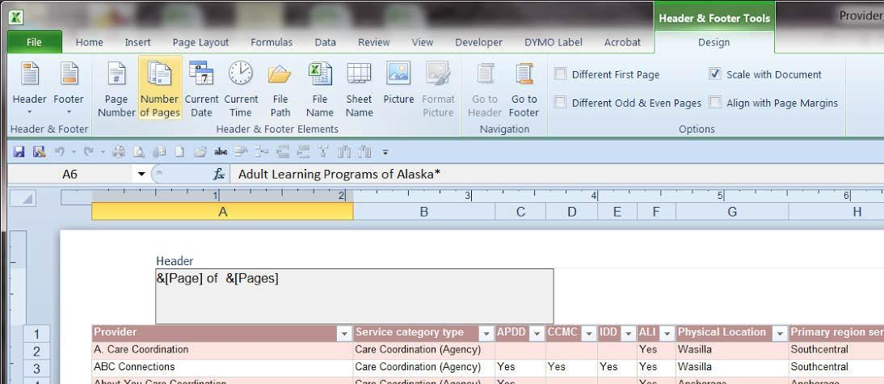

* Add Page Number (type )of then Number of Pages to the left header

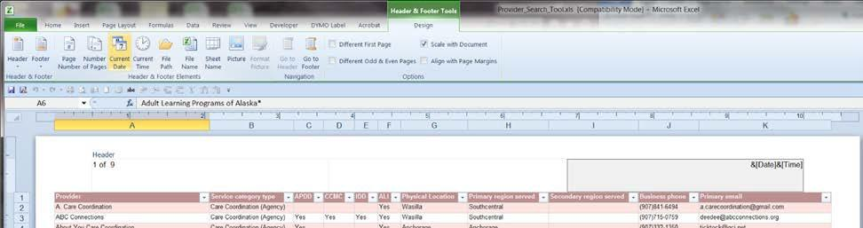

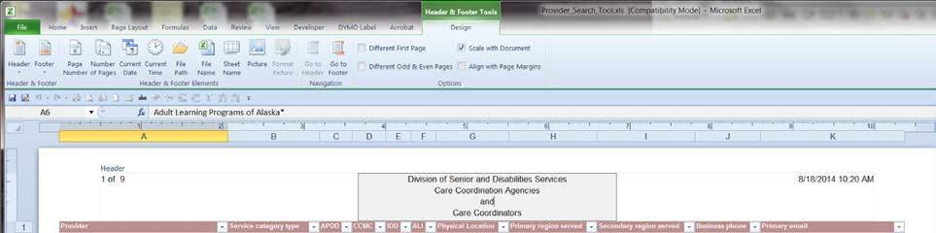

* In the center section enter:

Division of Senior and Disabilities Services Care Coordination Agencies

and

Care Coordinators

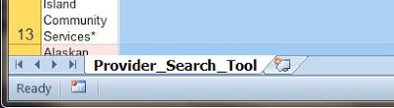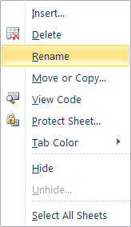

* Right click on the sheet name and Rename it to Services Provider List

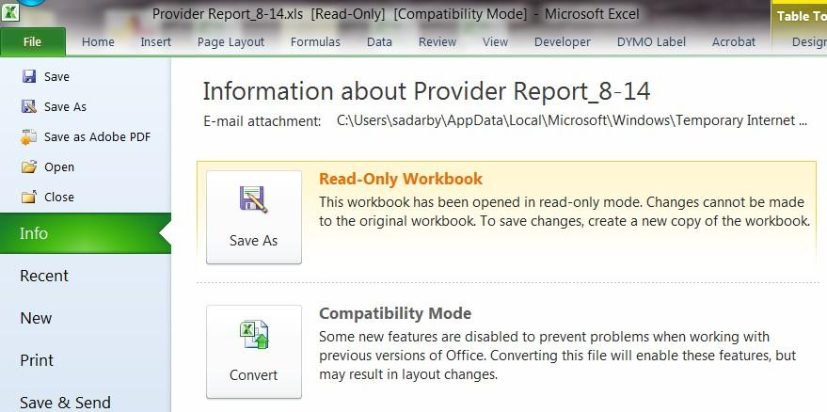

* Go to File → Convert to update the file format

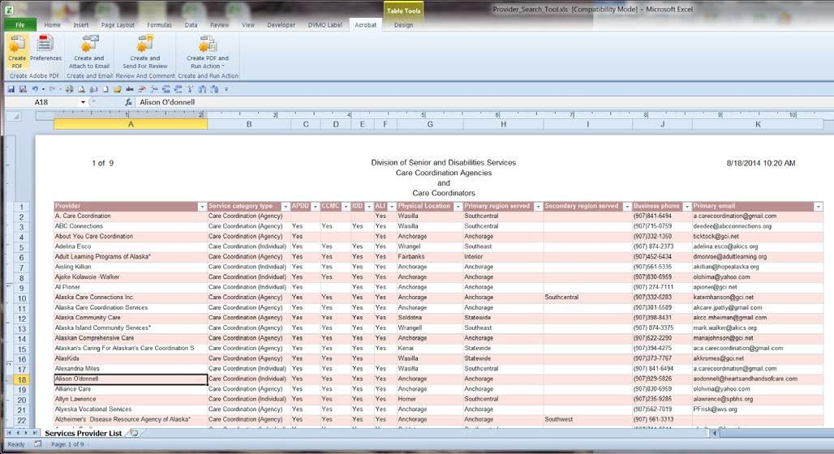

* Go to Acrobat → Create PDF

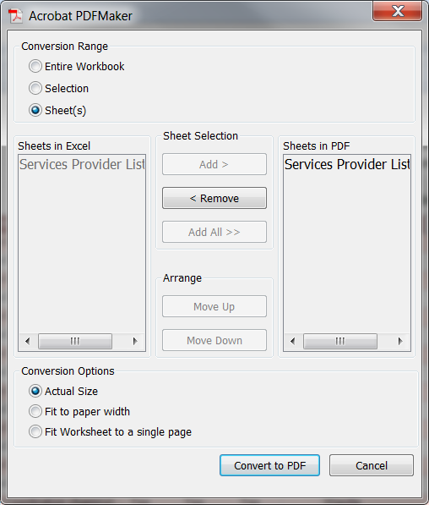

* Click Convert to PDF

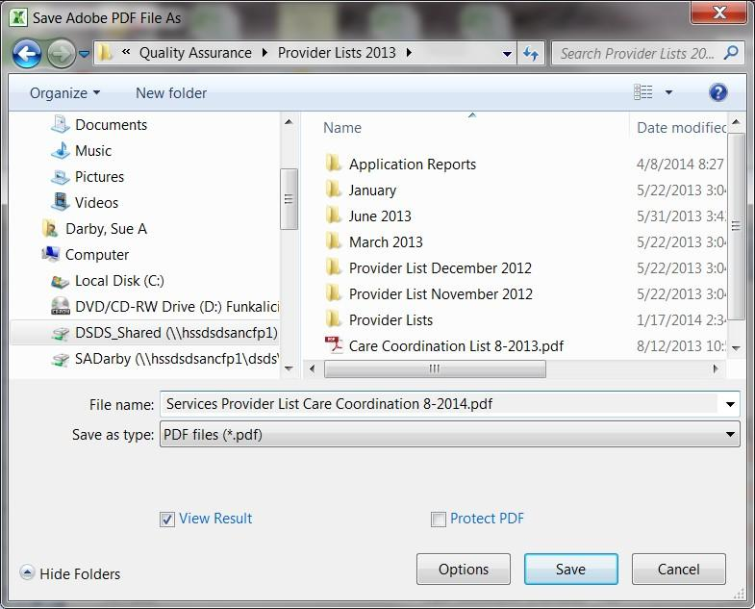

* When Prompted SAVE!
* Services Provider List Care Coordination and Current Month-Year
* Word & Adobe will convert the file and open it in Adobe when completed

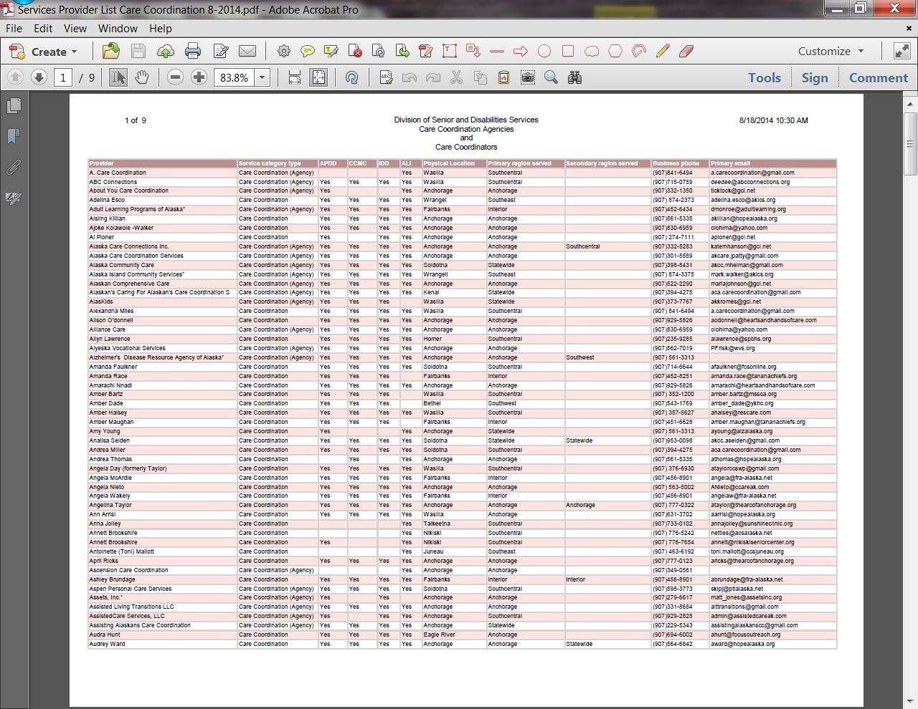

Completed file for posting

Send the file to Angela Salerno for posting to website. If requested to forward to Karen Copely also CC Lisa

**Career** **New Skills** **learning** **Python**

**Ruby** **PHP**

**Perl**

**One hour of code per day**

**Articles** **Books** **Website**

*IDE*

* Frameworks
  + CSS
  + HTML
  + Javascript
  + MySQL
    - Php
    - .net
    - Perl

*Coding*

* Unity
  + C#
* Linux
  + Shell
  + C
* Android
  + Android app

**Video** *Ted talk Udemy*

* Udemy video

*Learnable video*

*YouTube OSTraining*

**Industries** **Tech** **Services Software** **Support**

**Forum Moderation** **Social Media** **Consulting Energy** **Renewables**

*Solar* *Wind Hydro*

**Social Good** **Creative**

**Business Strategy Portfolio** **Physical**

**Resume** **Cover Letters**

**Profile base sites**

**Dice**

**Career Builder** **Alexsys** **LinkedIn**

**Skill Expansions**

**Charter Microsoft Udemy**

**Sitepoint**

**Resume Plan**

**Summary**

**skills**

*9* Description*

* bullet accomplishments

*STC Description*

* Accomplishments

*SDS Description from PD*

* bullet accomplishments

**Education**

**Charter**

*BS AS*

*Honors* **Certifications** *MOS*

*Udemy list* **Job posts** **Cover letter Resume** *Tech Writing*

*Business Analyst Software Support* *Webmaster*

**Target Job Titles Business Analyst** **achievements**

*archives* *reports* **knowledge**

*medicaid*

* medical system

*certification*

*computers*

* programming languages
  + know
    - Basic
    - websites
      * HTML
      * Css
      * Javascript
  + software
    - data tracking
    - excel

**project planning**

*project management*

* tracking
* lists

**helping others**

*problem solving*

* research
* learning

**Technical Writing**

**writing**

*story telling* **Webmaster Software Support** **new software** *testing*

**Teaching**

**Web Development** **Wordpress management** *Not content writing* *Plugins*

*Page setup Posting content* *Updates* *Configuration* *Theme setup*

**Programming functionality**

*.net* *Javascript* *Html*

**Data Analytics** **Social media** **Data analysis** *Big data*

*Data manipulation* *Results*

*Improve systems* *process improvement* **WordPress**

*Theme Development* *Plugin Development*

**Questions**

**What niche am I targeting?**

**What specific industries?** **Who is in my niche industry? Are they hiring?**

**Who do I know that can help me?** **What are the company's pain points? How can I help them?**

**What skills do I have that can solve their problem?** **Cloud Services**

*Google Apps* *DropBox* *Toodledo*

*Hootsuite*

* bank accounts

*Ms office*

* Documents formatting
* Reports
* Integration between apps

**What size company am I targeting?**

**Webmaster**

**what types of businesses do I want to work with**

*what website development businesses are there locally*

* could I work for one of them
* what websites locally SUCK

**What area of web dev do I want to focus on**

*do I want to hand code mySQL sites*

*do i want to learn to develop my own plugins* *what CMS do I want to work with*

* WordPress
* Drupal

**Site**

**Lady Code Monkey**

**code samples**

*different programming languages*

* Javascript
* .net
* basics in HTML
* Basics in CSS
* screenshots of back end tech languages or snippets formatted with HTML5 and CSS in pages or posts

*each page shows new functions learned*

* show progression of learning
* basics to intermediate to advanced topics as well as linked skills

*Code Combat Levels and scores*

*Use Udemy samples from classes as pages*

* Manually code items and link to them in posts or pages
  + link posts or pages to portfolio and AOS for sample items of services

**Website**

*Ensure settings are good*

* link with social media
  + add content
* Add Materials from Evernote
* Add older items from found documents

**Presentations**

**Procedure snippet** **OneNote shots**

**Mind maps or thought processes** **Reports**

*Ad hoc Regular*

**screenshots of work**

**code** **gui reports** **forms**

**website clips tools**

**Add accomplishements and achievements and projects to site** **Add completed classes to LinkedIn**

**Transition Out**

**Files**

*Pull* *Inventory Cc* *Offsite*

*Electronic* **Reports** *Weekly* *Ad hoc*

*Maintenance* **Copier** **Archives**

*Old* *Jan 16*

*Jul 16*

*Closed*

* Voluntary
* Involuntary

**Letters** *Merges Envelopes* *Pdf*

**Data clean up**

*Reshab Cc*

*Cir*

*Data merge*

**Goals**

**Personal writing**

*Reverse job description*

*what do i know that others might not?*

* how do i develop a tool to match a process
* projects
  + books
    - pattern styles
      * diagrams
    - writing a book
      * tools to use
        + Evernote
        + Scribus
        + Freeplane
      * photography
        + photo editing
      * new patterns
        + which dolls
  + as books
    - pattern kits
    - pattern lines
    - book of patterns?

**Organize Portfolio**

**GoogleDrive** *sue.a.darby GoogleDrive* **EverNote**

**HardDrive DropBox Achievements Presentations** *Procedure snippet OneNote shots*

*Mind maps or thought processes*

**complete archives** **complete procedures Master Settings Workbook**

*reduced work load time by 85%*

**Reports** *Ad hoc Regular* **KSA**

*Current work*

* Check list edits
* Date stamping
* DS3 updates

**Certification or QA Email Box Management**

SST has access to this box and uses flags and categories to filter through the messages that need action by the SST or other staff. SST & unit manager are box owners but all staff should have access to box to take action.

1. CPR Waivers or BCU Expedites
   1. Requests come into box.
   2. SST flags and categorizes as CPR or Expedite.
   3. MAA II or HPM III views inbox for their category and takes required action.
   4. When item is completed clicks flag to turn it into a checkmark.
   5. SST moves finished items to appropriate CPR or BCU Expedite folder for archiving.
2. Certification Application Materials
   1. New Applications are forwarded to OA II for processing.
   2. Change forms are forwarded to appropriate professional staff by alpha split.
   3. Once materials have been forwarded original emails are moved to Certifications folder.
3. Fiscal intermediary reports
   1. Reports come in on Mondays.
   2. After SST has viewed report and taken action report is moved to Certification Actions folder.
4. BCU notifications
   1. All BCU communication is moved to BCU folder for action by other staff.
5. Miscellaneous questions or other correspondence are taken care of by SST on a case by case basis either by replying to sender or forwarding to appropriate staff.
6. QA Box
   1. E-alerts are moved to E-alert folder
   2. Any misc certification materials are moved to Certification box and categorized as sent to wrong email along with any other categories or flags so that staff can provide technical assistance to sender regarding communications as well as take action on the item.

This is the professional online portfolio of Sue A. Darby of Alaska.

Sue is currently an Office Assistant II with the State of Alaska’s Senior & Disabilities Services Quality Assurance Provider Certification unit.Sue is currently a team lead for 2, packet screener and technical assistant to a primary group of 6 professional staff and a secondary support for an additional group of 5 Service Quality Assurance professional staff.

Among Sue’s accomplishments are website design, blog development, published author, and technical writing.

Sue completed her studies in Business Management & Information Technology at Charter College in 2009. During the course of her studies she obtained a Microsoft Office Master Certification for Microsoft Office 2003 and a high level of working knowledge with Office 2007 including State of Alaska Training. She is frequently asked by bosses, supervisors and co-workers for help with solving real world problems, programs and applications.

Sue does this with enthusiasm and is always willing to lend a hand. On this site are;

[Sue’s Curriculum Vitae](http://www.sue-a-darby.com/about-2/resume/) [Certifications](http://www.sue-a-darby.com/about-2/resume/education/)

[Degrees](http://www.sue-a-darby.com/about-2/resume/education/) [Training](http://www.sue-a-darby.com/about-2/resume/education/training/) [Awards](http://www.sue-a-darby.com/about-2/resume/education/awards/)

Please also visit her [blogs](http://blog.sue-a-darby.com/) and other [websites](http://www.sue-a-darby.com/blog-website-network/) to further view examples of her work in writing and web development.

Greatest Strengths

Streamlined Management Information Systems input, reduced time consumption by 50%

Goal oriented- sets and achieves goals brainstorms to improve processes that are inefficient thus increasing productivity or otherwise improving the workplace Ability to communicate with both technical and non-technical users

Graduated Alpha Beta Kappa

Establish positive and consistent customer relations Maintains high integrity and work standards

Present lectures & conduct discussions to increase knowledge & competence Certified In MS Office 2003

Microsoft Office Master – March 2009

Microsoft Office Specialist Access – November 2007

Microsoft Office Specialist/Expert Excel – September 2007/March 2009 Microsoft Office Specialist Power Point – September 2007

Microsoft Office Specialist/Expert Word – March 2007/October 2007 Proficient In

Windows 3.1, XP, Windows 2000, Server 2003R2 Visual Basic.NET, OneNote, Project 2003, Outlook, Visio Office 2007, OpenOffice 3.0

Corel Draw, Dreamweaver MX, MX 2004, CS3

Flash CS3, FireWorks CS3, Illustrator, PhotoShop

Internet Explorer, FireFox, Thunderbird, Google Chrome, Safari HTML, CSS, Drupal, Joomla, WordPress

Ethical White Hat Search Engine Optimization Techniques

2004

Chugiak Children’s Services Head Start Classroom Aide Volunteer

Assist with craft projects

Provide additional adult supervision & support to 20+ pre-school classroom Yard duty including maintaining observation of rules by youngsters

2003

Web site Marketer for [www.integrity-designs.com](http://www.integrity-designs.com/) Volunteer

Search engine submission, classified ad placement, online groups marketing where appropriate. Other marketing duties as assigned by owner.

2003

Graphic Designer for [www.minidolllist.com](http://www.minidolllist.com/) Volunteer

Designed display cards for St Louis Miniatures Museum display September 2003. Designed Library Cards for the Miniature Doll University.

July 1992 to 2002

Shirley’s Creative Designs Production Assistant Volunteer

Seamstress Data entry Graphic art

Studio style photography

Web site design & maintenance (not current version) Trouble shoot pattern drafting problems

Draft patterns, computer trouble shooting

**B.S. Business Management Practice, B.S. Business Management & Technology,**

* 1. **Business Management Practice, Certificate Office Applications – with Honors**

April 2006 to April 2009

Charter College Anchorage , AK **Website Development & Design** May 2003 to present

[GNC Web Creations](http://www.gnc-web-creations.com/) Universal City, TX

**Business Marketing**

August-December 2005

University Alaska Southeast Juneau , AK

Awards

Charter College – Anchorage, AK – June 2009 Alpha Beta Kappa

June 2006 to April 2009 Dean’s List

Fasion Design (Certificate with Honors) September 1995 to May 1997

Solano Community College Suisun, CA

Solano Community College Suisun , CA - May 1997 Alpha Gamma Sigma Honors Society (Lifetime Member)

Certifications

Nine Star Education & Employment Services Anchorage , AK Microsoft Office Master - March 2009

Microsoft Office Specialist/Expert Word - March 2007/October 2007 Microsoft Office Specialist Power Point - September 2007

Microsoft Office Specialist Access - November 2007

Microsoft Office Specialist/Expert Excel - September 2007/ March 2009 National Computer Science Academy Dallas , TX

Microsoft Word 2002 - November 2006 Microsoft Power Point 2002 - November 2006 Microsoft Access 2002 - November 2006

Professional Organizations & Seminar-Workshops Balancing Life & Work John Parker

Anchorage , AK – August 2007 Novel Install Fest IT Expo Anchorage , AK – October 2006

AmeriCorps Conference National Association for Community Volunteerism Anchorage , AK – April 2006 & 2007

Professional Memberships

Association of Information Technology Professionals

Charter College Anchorage , AK – October 2006- October 2009

Interests

Writing, web design, dolls, computers, gardening, sewing, crafts, business, reading fiction & non-fiction

**Additional Training Courses**

Introduction to Share Point with Lab April 2011

HIPAA Security 201 Training State of Alaska Senior & Disabilities Services March 2011 Introduction to Supervisor Training March 2011

Basic Care Coordination Training for Quality Assurance State of Alaska Senior & Disabilities Services March 2010

Introduction to Office 2007 May 2009

[Sample Resume- Kris Kringle](http://kringle/) Monday, November 8th, 2010

Even Santa should have a good resume. This was a sample resume created to make clients and co-workers alike smile at the collection of skills that [Kris Kringle](http://blog.sue-a-darby.com/2010/11/sample-resume.html/) has.

[Team Leaders](http://www.sue-a-darby.com/2010/11/responding-professionally-to-change-in-the-workplace.html/)

Monday, November 8th, 2010

A short presentation on [Team Leadership](http://blog.sue-a-darby.com/2010/11/team-leaders.html/). [Tutorials](http://www.sue-a-darby.com/2010/11/tutorials.html/)

Monday, November 8th, 2010

The first of my original work tutorials is my [Crash Course on Pattern Drafting in](http://blog.suestinycostumes.com/2010/07/03/pattern-drafting-crash-course-for-a-child-doll.html/) [Miniature](http://blog.suestinycostumes.com/2010/07/03/pattern-drafting-crash-course-for-a-child-doll.html/). This tutorial is a very long one so I will simply direct viewers to my [Tutorials](http://blog.suestinycostumes.com/) [Blog](http://blog.suestinycostumes.com/) to view it. All the diagrams are my own work and also appear in my published & copy written books [Pattern Drafting for Miniatures](http://suestinycostumes.com/products/books/books.html) and some of the material can also be found in my book[Pattern Making for Dolls](http://suestinycostumes.com/products/books/books.html).

[Responding Professionally to Change in the Workplace](http://www.sue-a-darby.com/2010/11/responding-professionally-to-change-in-the-workplace-2.html/) Monday, November 8th, 2010

A short presentation on [Responding to Change in the Workplace](http://blog.sue-a-darby.com/2010/11/responding-professionally-to-change-in-the-workplace-2.html/).

1

**Date Stamper Instructions**

**All Documents**

* + 1. Clear settings – press the Stop/Clear button then Yes
    2. Insert the documents face up with footer to the right side
    3. Push Mode then Start.
    4. Line ID press 1 and Start
    5. Selected Line just ignore and press Start
    6. Enter Alpha using the keypad (multiple press on same key for different numbers and letters) always enter “SDS QA” as the start, then the date the item was rec’d i.e. SDS QA FEB 19 2013 Note that FEB will also require using the Yes/No Arrow keys to move from the “F” to the “E”
    7. When SDS QA and the date are entered push Start
    8. Ignore Enter Digits and push Start again

**Transport errors**

Transport errors happen when staples are missed in preprocessing of the documents. Some paper types also cause Transport Errors for unknown reasons.

**To clear a transport error:**

1. Gently pull the paper out either from the top or the bottom of the machine
2. Push the Stop/Clear button to continue
3. Determine if it needs to be sent through a second time and either push Yes or No

If multiple packets of documents are on the same date you can simply clear the counter and push start again for the same date but a restart of the Bates Numbering function.

Date Stamper Instructions 2-2013

What do I want?

What do I really want for a career? I know it won't be a job or just a paycheck. I really need something that makes my heart sing. But what is the "thing" that would do that? I have a number of things I love doing. I love to help others but I hate sales and retail. I love to help those who want my help and seek out my knowledge. I will bend over backwards to come up with everything I can to answer their problem or issue. If it's in my power to do it I will. Yes, that kind of work makes my heart sing. I want to also learn. Anyone who wants to learn something from me likely has something they can teach too. So I want to learn from others. If that is from a book or talking to them or information they can share or things they could do for me all the better.

But really what is this elusive career called? Happiness Creator? Information Sharer? Information Coordinator? I think it has to do with information and data and that is partially why I love building reports and tracking processes and information. Add in some statistics and writing amusingly enough and even a dash of accounting or inventory management and it might be the right mix. I manage stuff very well. I can manage people only fairly well. I can do it and enjoy it but only if I've chosen my team.

I would love to do something with code as well as writing content. Small code tweaks are fun and challenging which provides a great learning opportunity.

Favorite things to do

1. Code
2. Document management
3. Document creating
4. Format
5. Writing
6. Reports
7. Data processing
8. Help others
9. Troubleshooting
10. Draft Patterns
11. Sew

Realistically I am best at #2-9 with a hobby level love of 1, 10 & 11 but in the right job I am kick butt at them as well I just haven't found the right combination that lets me make a living doing them #2-9 are things that are part of my current day job and are the best parts of it. If I was to be perfectly honest the things that dive me crazy about my current job are the hard copy files. They are a MESS and have been from the start. Only recently have they started to look good and even now there are some issues which thankfully keeping an electronic duplicate of the file can fix.

What do I do well and enjoy and where does that intersect a living for me? Computers, documents, data and how can it help others either informatively or to do their job more efficiently. If the job let me either draft or sew as well I would love it even more as I would be using ALL of my education not just the Bachelors degrees

So does anyone have ideas for job titles that fit this description to use for search terms or any instant setup businesses (LOL I know no such thing ) to try?

|  |  |
| --- | --- |
| **File Naming Structures for All Document Types**  “Date” = Date of creation of the document. Month, day, year. Example 8-17-14. For letters being mailed, use the date of mailing. | |
| **INITIAL CERTIFICATION FORM** “Agency Name,  Initial Cert, Date ” (Acme Agency, Initial Cert, 12- 13-2010) | **LETTERS** “Agency Name, Type of Letter, date” (Acme Agency, Notice to Correct, 01-2-2012). |
| **RECERTIFICATION FORM** “Agency Name,  Recert, Date” (Acme Agency, Recert 1-21-12)  **INITIAL CARE COORDINATOR CERT FORM**  (File under agency folder) “CC Last Name, CC First Initial, Initial Cert, Date (Smith, J, Initial Cert, 12-13-14)  **AMENDED CERTIFICATION FORM “**Agency  Name, Amended, Date ” (Acme Agency, Amended Cert, 12-13-2010) or (Acme Agency, Amended Cert2, 12-13-2010)  **AUDITS** “Agency Name, Audit, date” (Acme Agency, Audit, 01-2012)  **CARE COORDINATOR CHANGE OF**  **AFFILIATION** (File under both agency’s folders) “CC Last Name, First Initial, Change of Affiliation, Date” (Smith, J, Change of Affiliation, 6-13-14) | **CHECKLISTS** “Agency Name, Waiver or PCA App or recert Checklist, Date ” (Acme Agency, PCA App Checklist, 12-13-2010)  **CARE COORDINATOR RECERT FORM** (File  under agency folder) “CC Last Name, CC First Initial, Recert, Date” (Smith, J, Recert, 12-13-14)  **END CERTIFICATION FORM** “Agency  Name/CC Last Name, First Initial, End Cert, Date (Acme Agency, End Cert, 6-30-14; Smith, J, End Cert, 6-30-14)  **CPR & FA PCA WAIVERS** “CPR/FA, Last  Name First initial, Date” (CPR/FA, McGuire L, 8/17/14)  **PEND LETTER “**Agency Name, Pend Letter, date” (Acme Agency, Pend 2, 1-2-12). |

|  |  |
| --- | --- |
| **Acceptable Service Abbreviations:** |  |
| * **Care Coordination Services** | (CMG) |
| * **Residential Habilitation Services** | (ResHab  ) |
| * **Day Habilitation Services** | (DayHab  ) |
| * **Supported Employment Habilitation Services** | (SE) |
| * **Adult Day Services** | (ADS) |
| * **Residential Supported Living Services** | (RSL) |
| * **Respite Services** | (Resp) |
| * **Intensive Active Treatment Services** | (IAT) |
| * **Environmental Modification Services** | (Emod) |
| * **Chore Services** | (Chore) |
| * **Transportation Services** | (Trans) |
| * **Meal Services** | (Meal) |
| * **Nursing Oversight & Care Management** | (NOCM) |
| * **Personal Care Assistance** | (PCA) |

##### File Layout 10-4-2013

**Section 1 Certification (all agencies)**

* 1. **Certification forms**
  2. **Checklist**
  3. **Correspondence**

**Section 2 Application & Agency Training ( All Agencies)**

* 1. **Application forms** (All Forms except Administrator Appointment)
  2. **CIR training certificate Section 3 Business Information**
  3. **Business license**
  4. **Certificate of Insurance**
  5. **Personnel Info**
     + Organizational Chart
     + Personnel List
     + BCP information (Including Internal Form) 3-4 **Annual Report**
     + Quality Improvement Report
     + Medication Administration Report
     + Restrictive Intervention Report (See 5-1 J for Policy) 3-5 **Licenses**
     + Current ALH license
     + List of Habilitation homes

1. Habilitation Home Licenses
2. Contracts
   1. **Transportation (transportation- both)**
      * Vehicle Registration
      * Local Permits
   2. **Meals**
      * Food permit
      * 5-week menu cycle

**Section 4 Program Administrator(s)**

(May have more than one set if Administrators are different for each program) 4-1 **Program Administrator Appointment Form/s**

* 1. **Attachments**
     + Resume
     + Educational Qualifications

**Section 5 Policies & Procedures**

* 1. **Operations Manual P & P’s**
     1. Admissions Policy
     2. Complaint Management
     3. Conflicts of Interest
     4. Confidentiality
     5. Critical Incident Reporting
     6. Emergency Response
     7. Financial Accounting
     8. Medication Administration
     9. **Quality Improvement** Policy
     10. Restrictive Intervention
     11. Termination of Provider Services 5-2 **Core employee policies**
* Background Check
* Training
* Employee Evaluation (NOT currently Required) 5-3 **Specific Service Requirements**
* Care Coordination: Plan of Care policy/procedures; Conflict of Interest; disclosure of ownership statement
* Adult Day: Participant handbook; Building permit; posted emergency procedures; floor plan; ADS service plan
* Day Habilitation services (for unlicensed site-based ): Building or use permit and posted emergency evacuation procedures

**Section 6 Permanent Data**

6-1 **Notices and/or adverse actions** (Sanction notices, Notices to Correct, Records Requests, Other notices

***EXPERIENCE New***

***State of Alaska, Division of Senior & Disabilities, Quality Assurance, Provider Certification & Compliance Unit***

Office Assistant II May 2008 to Present Anchorage, AK

***Nine Star Education & Employment***

Career Development Center Mentor & Computer Instructor April 2006 to April 2008

Anchorage, Alaska

[***Sue's Tiny Costumes***](http://www.suestinycostumes.com/)Owner Webmaster Author 1996 to present

### *Additional Work Experience*

[Books, Music & More](http://www.books-music-more.com/)

Site Owner 2008-Present

[Alaska Office Specialists](http://www.alaskaos.com/)

Site Owner 2008-Present

Coffee Institute

Site Owner 2008-Present

***Michael’s Arts & Crafts***

Cashier, Stock Clerk, Events Coordinator Portland, OR

***New Marine World Theme Park***

Outback Gift Shop Clerk Vallejo CA

***Steamboat Ski Corp*** Food Service Cashier Steamboat Springs, CO

***Hamilton Stores***

Fountain Cashier Steamboat Springs, CO

***Solano College Fashion Design Department***

Computer Tutor Suisun, CA

***Camp Rotary***

Arts & Crafts Counselor Boxford, MA

***Marine World***

Food Service Cashier Vallejo, CA

***House of Fabrics*** Floor Clerk Fairfield, CA

### *Volunteer Work*

###### *PRIDE Program Rasmussen*

Grant Writer 2008

***Chugiak Children's Services Head Start***

Classroom Aide 2004

[***www.integrity-designs.com***](http://www.integrity-designs.com/)

Web site Marketer 2003

[***www.minidolllist.com***](http://www.minidolllist.com/)

Graphic Designer 2003

***Shirley's Creative Designs*** Production Assistant July 1992 to 2002

***SKILLS New***

###### *Administrative*

1. Ability to understand, analyze, apply, & explain complex program statutes, regulations, policies, & procedures
2. Adjust workflow to complete critical tasks in a timely manner
3. Develop specific process for processing archival & offsite storage of files
4. Brainstorm ways to streamline the administrative processes
5. Procurement of supplies for equipment & team
6. Answer phones & questions from the public
7. Process all incoming mail & any special handling for outgoing mail

***Writing- Business, Creative & Technical***

1. Policy & procedure development
2. Maintain records of files & version controls
3. Write technically detailed, illustrated instructions for processes & doll patterns
4. Write, proofread & edit professional correspondence communicating important information & requirements to recipients in clear & concise manner
5. Proofread for grammar, style, content & spelling
6. Grant writing based on data, knowledge & interviews with SMEs
7. Follow guidelines for APA papers

***Computers***

1. Communicates effectively with both technical & non-technical users
2. Software & hardware user support
3. Troubleshoot Office 2007 & 2010, peripherals, network printers & laptops
4. Create templates to generate reports
5. Develop Statistics report for use in grants
6. Develop training materials for various processes, present to co-workers & management
7. Design charts & graphs for Department, State & Federal reports
8. Design, develop & maintain multiple websites & blogs
9. Mail merge letters & labels creating both forms, letters & spreadsheets as necessary
10. Input client data & statistics into database

***Software & Programming***

1. MS Office 95-2010, MS Project, Master Certified Office 2003; Open Office
2. SharePoint (site owner)
3. Visio, Star UML, Dia,
4. Corel Draw, Inscape, Gimp, Paint Shop Pro
5. HTML, CSS, WordPress, Javascript, Visual basic, BASIC A, Perl
6. Chrome, Firefox, Opera, Internet Explorer
7. Windows 3.1, 95, XP, Server 2003, Win 7; Linux Suse, Ubuntu; Android
8. File Maker Pro, Citrix, Dreamweaver

***Business Management***

1. Manage small business including product development, class development, web design & maintenance, marketing & budget
2. Brainstorm process improvements, make suggestions, implement approved plans & write technical documents for process revising as necessary
3. Research & write business, marketing, & merchandising plans
4. Project management including task management, goals, timelines and GANTT Charts
5. Set project goals, determine risks, prepare contingency plan, & time line for

achievement

1. Collect & analyze data on customers to identify potential markets

***Teaching***

1. Organizing training sessions; materials gathering, staff/location coordination, equipment setup
2. Develop class curriculum
3. Teach computer classes to adults
4. Teach goal setting workshops
5. Develop basic computer classes or work one on one with students to develop skills
6. Answer student questions about various software applications
7. Aid students in preparation for the Microsoft Office Specialist exams
8. Distance Education Teacher for pattern drafting classes
9. Assist with craft projects in a school & camp setting
10. Develop classes & teach as a Camp Counselor
11. Provide additional adult supervision & support to 20+ student pre-school classroom
12. Yard duty including maintaining observation of rules by youngsters

***Web Site Development***

1. Web site design & maintenance of hand coded websites
2. Install & maintain Wordpress sites
3. Proficient in white hat SEO techniques
4. Track keywords, visitors & other analytical data for each site
5. Troubleshoot hosting issues

***Marketing***

1. Write marketing plans for businesses
2. Develop advertising for various business websites
3. Search engine submission, classified ad placement, online groups marketing where appropriate.

***Career Development***

1. Assess clients for barriers & brainstorm ways to overcome them
2. Draft & edit resumes, cover letters & other business correspondence
3. Confer with clients to determine what program will be most helpful
4. Conduct job-matching to find good fit between clients & hiring companies
5. Direct clients to appropriate resources & assists clients in their use of outside assistance

***Additional Skills***

1. Trouble shoot pattern drafting problems
2. Draft patterns, computer trouble shooting

***Linked In***

* Ability to understand, analyze, apply, & explain complex program statutes, regulations, policies, & procedures
* Communicates effectively with both technical & non-technical users
* Adjust workflow to complete critical tasks in a timely manner
* Develop specific process for processing archival & offsite storage of files
* Policy & procedure development
* Maintain records of files & version controls
* Write technically detailed, illustrated instructions for processes
* Master Certified Office 2003, SharePoint (site owner)
* Visio, Star UML, Project,
* Organizing training sessions; materials gathering, staff/location coordination, equipment setup
* Train additional staff on various processes & assign tasks overseeing accuracy



* Manage small business including product development, class development, web design & maintenance, marketing & budget
* Write technically detailed, illustrated instructions for processes & doll patterns
* Distance Education Teacher for pattern drafting classes
* Research & write business, marketing, & merchandising plans
* Project management including task management, goals, timelines and GANTT Charts
* Set project goals, determine risks, prepare contingency plan, & time line for achievement
* Collect & analyze data on customers to identify potential markets
* Web site design & maintenance of hand coded websites
* Install & maintain Wordpress sites
* Proficient in white hat SEO techniques
* Track keywords, visitors & other analytical data for each site
* Troubleshoot hosting issues



* Organizing training sessions; materials gathering, staff/location coordination, equipment setup
* Develop class curriculum
* Teach computer classes to adults
* Teach goal setting workshops
* Develop basic computer classes or work one on one with students to develop skills
* Answer student questions about various software applications
* Aid students in preparation for the Microsoft Office Specialist exams
* Assess clients for barriers & brainstorm ways to overcome them
* Draft & edit resumes, cover letters & other business correspondence
* Confer with clients to determine what program will be most helpful
* Conduct job-matching to find good fit between clients & hiring companies
* Direct clients to appropriate resources & assists clients in their use of outside assistance

## *Duties new page*

1. Charged with design and development of Provider Certification & Compliance Internal SharePoint Site (Site Owner permissions)
2. Develop transition plan for team use of Share Point Site including Team Discussion Moderation, File Library and feature setup
3. Provide team with weekly charts showing application processing status
4. Participate in work groups for new regulations & new application offering ideas, & suggestions on requirements, processes & design
5. Provide technical assistance within scope of Quality Assurance, Provider Certification & Compliance
6. Team Lead for up to 3 volunteers; training & assigning tasks, checking work as needed
7. Screen Certification Packets, checking for completeness & updating databases as required
8. Manage multiple group e-mail boxes; directing messages or resolving issues as needed
9. Write & post various articles or pages on multiple sites
10. Manage & update up to 16 sites & blogs
11. Participate in a variety of business promotional activities on FaceBook, Twitter, LinkedIn & other groups & forums
12. Responsible for the CPR & First Aid training waivers processing
13. Receptionist duties; dealing with callers in crisis or seeking information, direct calls as appropriate
14. Support staff for Quality Assurance Unit, Provider Certification (team of 6) & Quality Assurance, Recipient Services (team of 8)

## *ACHIEVEMENTS new page*

1. Design display cards for St Louis Miniatures Museum display September 2003.
2. Design Library Cards for the Miniature Doll University.
3. Author of 2 published books, Pattern Drafting for Miniatures & Pattern Making for Dolls
4. Articles published in International Doll Magazine, Doll Castle News Dolls, Bears & Anywears, & Dolls In Miniature
5. Cut Management Information Systems input time by 50%
6. Develop over 100 miniature & small doll patterns By the year list achievements

Time line style fishbone diagram PUB AUTHOR

DATA ENTRY HAB PROJECT

UNIT SHAREPOINT

***PROJECTS new page***

**Dolls In Miniature** Smocked Dress **International Doll**

Kitty

Bo Peep

**Dolls, Bears & Anywears ARCHIVES procedure development**

**Habilitation Homes project from Idea to implementation**

***EDUCATION & TRAINING***

**Bachelors– Alpha Beta Kappa**

Business Management Practice

Business Management & Information Technology

**Associates**

Business Management Practice

Business Management & Information Technology

**Certificate**

Office Applications April 2006 to April 2009

Charter College Anchorage, AK

**Relevant Classes**

Technical Writing, Research Methodologies, Project Management, Telecommunications, Statistics, Business Law, Contract Management, Human Resources, Operations Management, Marketing

**Website Development & Design**

May 2003 to present

[GNC Web Creations](http://www.gnc-web-creations.com/) Universal City, TX

**Business Marketing**

August-December 2005

University Alaska Southeast Juneau, AK

**Fashion Design (Certificate)**

September 1995 to May 1997

Solano Community College Suisun, CA

***Certifications***

Microsoft Office 2003 Master - March 2009

Nine Star Education & Employment Services Anchorage, AK

***Training***

**State of Alaska**

Advanced SharePoint for Site Owners & Power Users June 2013 Introduction to Share Point with Lab April 2011

HIPAA Security 201 Training March 2011 Introduction to Supervisor Training March 2011

Basic Care Coordination Training for Quality Assurance March 2010 Introduction to Office 2007 May 2009

***Organizations, Memberships & Workshops***

Balancing Life & Work with John Parker Anchorage, AK - August 2007

Novel Install Fest IT Expo Anchorage, AK - October 2006

AmeriCorps Conference National Association for Community Volunteerism Anchorage, AK - April 2006 & 2007

***Professional Memberships***

Association of Information Technology Professionals

Charter College Anchorage, AK - October 2006- October 2009

***Other***

***PDF documents***

***Screen shots of projects Scans of magazine articles***

***EXPERIENCE Current***

***Do I want achievements here? Or just a list of positions with dates and places?***

***State of Alaska, Division of Senior & Disabilities, Quality Assurance, Provider Certification & Compliance Unit***

Office Assistant II May 2008 to Present

**Professional Achievements**

1. Convert New Provider Certification Application to fill in PDF for public use
2. Design & implementation of the “Habilitation Homes Project” to connect licensed homes with recipients & certified agencies; original “Critical Incident Report Tracking” system and statistics generation
3. Design charts & graphs for Unit, Department, State & Federal reports; UML diagrams, translate into written processes; gather information, develop content including graphics, proofread & edit technical documents

***Nine Star Education & Employment Anchorage, Alaska***

*Career Development Center Mentor/ Computer Instructor – AmeriCorps Member April 2006 to April 2008*

**Professional Achievements**

1. Reduce Management’s information systems data entry 50%
2. Statistic tracking & reporting for internal use & grants

[***Sue's Tiny Costumes***](http://www.suestinycostumes.com/) ***1996 to present***

*Web Based*

**Professional Achievements**

1. Published author of 2 books and 6 articles in various magazines
2. Product development
3. Website design, development, & marketing
4. Curriculum development for online classes

**Additional Work**

[***Books, Music & More***](http://www.books-music-more.com/) ***2008 to present***

*Web Based*

**Professional Achievements**

1. Article Writing, content development & information management
2. Topic research
3. Site marketing and social media management [***Alaska Office Specialists***](http://www.alaskaos.com/) ***2008 to Present*** *Web Based*

**Professional Achievements**

1. Article Writing, content development & information management
2. Topic research
3. Site marketing and social media management

***Coffee Institute*** House of Fabrics Camp Rotary Computer Tutor Hamilton Stores

Steamboat Ski Corp Wal-Mart

Michael’s Marine World

**Volunteer Work**

1. PRIDE Program Rasmussen - Grant Writer 2008
2. Chugiak Children's Services Head Start - Classroom Aide 2004
3. [www.integrity-designs.com](http://www.integrity-designs.com/) - Web site Marketer 2003
4. [www.minidolllist.com](http://www.minidolllist.com/) - Graphic Designer for 2003
5. Shirley's Creative Designs - Production Assistant July 1992 to 2002

***SKILLS Current***

***Business Management***

***Link to post regarding skill set with further details as if describing for job interview***

***Add skills retail, event planning & management, merchandising, customer service, inventory management***

***Organize skill sets by best to worst? By favorites? Sub categories? Most experience to least? Strongest to weakest?***

1. Manage small business including product development, class development, web design & maintenance, marketing & budget
2. Brainstorm process improvements, make suggestions, implement approved plans & write technical documents for process revising as necessary
3. Team Lead for up to 3 volunteers
4. Participate in work groups for new regulations & new application offering ideas, & suggestions on requirements, processes & design
5. Collect & analyze data on customers to identify potential markets
6. Research & write business, marketing, & merchandising plans
7. Set project goals, determine risks, prepare contingency plan, & time line for achievement
8. Project management including task management, goals, timelines and GANTT Charts

***Marketing***

1. Search engine submission, classified ad placement, online groups marketing where appropriate.
2. Participate in a variety of business promotional activities on FaceBook, Twitter, LinkedIn & other groups & forums
3. Develop advertising for various business websites
4. Write marketing plans for businesses

***Web Site Development***

1. Web site design & maintenance
2. Install & maintain Wordpress sites
3. Troubleshoot hosting issues
4. Write & post various articles or pages on multiple sites
5. Manage & update up to 16 sites & blogs
6. Track keywords, visitors & other analytical data for each site
7. Proficient in white hat SEO techniques

***Computers***

1. Communicates effectively with both technical & non-technical users
2. Software & hardware user support
3. Troubleshoot Office 2007 & 2010, peripherals, network printers & laptops
4. Mail merge letters & labels creating both forms, letters & spreadsheets as necessary
5. Create templates to generate reports
6. Input client data & statistics into database
7. Develop Statistics report for use in grants
8. Develop training materials for various processes, present to co-workers & management
9. Design charts & graphs for Department, State & Federal reports
10. Provide team with weekly charts showing application processing status
11. Design, develop & maintain multiple websites & blogs
12. Manage two group e-mail boxes in addition to primary & secondary inbox

***Software & Programming***

1. HTML, CSS, WordPress
2. Javascript, Visual basic, BASIC A, Perl
3. Corel Draw, Inscape, Gimp, Paint Shop Pro
4. MS Office 95-2010, MS Project, Master Certified Office 2003; Open Office
5. Visio, Star UML, Dia,
6. Windows 3.1, 95, XP, Server 2003, Win 7; Linux Suse, Ubuntu; Android
7. HTML, CSS, Visual Basic, JavaScript, Perl
8. Chrome, Firefox, Opera, Internet Explorer
9. File Maker Pro, Citrix, Dreamweaver

***Administrative***

1. Cut Management Information Systems input time by 50%
2. Brainstorm ways to streamline the administrative processes
3. Answer phones & questions from the public
4. Process all incoming mail & any special handling for outgoing mail
5. Organizing training sessions; materials gathering, staff/location coordination, equipment setup
6. Screen Certification Packets, checking for completeness & updating databases as required
7. Responsible for the CPR & First Aid training waivers processing
8. Monitor compliance with the new requirements for training
9. Backup for receptionist; dealing with callers in crisis or seeking information
10. Provide technical assistance within scope of Quality Assurance, Provider Certification
11. Support staff for Quality Assurance Unit, Provider Certification (team of 6) & Quality Assurance, Recipient Services (team of 8)
12. Develop specific process for processing archival & offsite storage of files
13. Ability to understand, analyze, apply, & explain complex program statutes, regulations, policies, & procedures
14. Adjust workflow to complete critical tasks in a timely manner
15. Procurement of supplies for equipment & team

***Career Development***

1. Confer with clients to determine what program will be most helpful
2. Assess clients for barriers & brainstorm ways to overcome them
3. Draft & edit resumes, cover letters & other business correspondence
4. Conduct job-matching to find good fit between clients & hiring companies
5. Direct clients to appropriate resources & assists clients in their use of outside assistance

***Creative***

1. Assist with craft projects in a school & camp setting
2. Develop classes & teach as a Camp Counselor for elementary & Jr High students
3. Design display cards for St Louis Miniatures Museum display September 2003.
4. Design Library Cards for the Miniature Doll University.

***Writing- Business, Creative & Technical***

1. Graphic art
2. Studio style photography

* Seamstress

1. Author of 2 published books, Pattern Drafting for Miniatures & Pattern Making for Dolls
2. Articles published in International Doll Magazine, Doll Castle News Dolls, Bears & Anywears, & Dolls In Miniature
3. Develop over 100 miniature & small doll patterns
4. Proofread for grammar, style, content & spelling
5. Grant writing based on data, knowledge & interviews with SMEs
6. Follow guidelines for APA term papers
7. Maintain records of files & version controls
8. Policy & procedure development

***Teaching***

1. Provide additional adult supervision & support to 20+ student pre-school classroom
2. Trouble shoot pattern drafting problems
3. Draft patterns, computer trouble shooting
4. Develop class curriculum
5. Teach computer classes to adults
6. Answer student questions about various software applications
7. Aid students in preparation for the Microsoft Office Specialist exams
8. Distance Education Teacher for pattern drafting classes
9. Yard duty including maintaining observation of rules by youngsters
10. Teach goal setting workshops
11. Develop basic computer classes or work one on one with students to develop skills

Support staff for Provider Quality Assurance & Compliance

Reports for Centers for Medicaid & Medicare Services, State Commissioner, Department of Health & Social Services, and Provider Certification Quality Assurance Unit

Brainstorm process improvements, make suggestions, implement approved plans, & write technical documents for process revising as necessary.

UML diagrams of process to show flow of steps and order is correct

Team Lead for up to three volunteers

Participate in work groups for new regulations & new application offering ideas, & suggestions on requirements, processes, & designing of new application, forms

Set project goals, determine risks, prepare contingency plan, & time line for achievement

Project management including task management, goals, timelines, and GANTT Charts

Brainstorm ways to streamline the administrative processes

Process all incoming mail & any special handling for outgoing mail

Organizing training sessions; materials gathering, staff/location coordination, equipment setup

Screen Certification Packets, checking for completeness & updating databases as required

Compare data from Access Database and update main database in multiple locations

Responsible for the CPR & First Aid training waivers processing and tracking

Monitor compliance with the new requirements for training

Backup for receptionist; dealing with callers in crisis or seeking information

Provide technical assistance to providers within scope of Quality Assurance, Provider Certification

Develop specific process for processing archival & offsite storage of files

Ability to understand, analyzes, apply, & explain complex program statutes, regulations, policies, & procedures

Adjust workflow to complete critical tasks in a timely manner

Procurement of supplies for equipment & team

Manage small business including product development, class development, web

design & maintenance, marketing & budget

Develop over 100 miniature & small doll patterns, including diagrams and technical detailed instructions

Author of 2 published books, Pattern Drafting for Miniatures & Pattern Making for Dolls

Articles published in International Doll Magazine, Doll Castle News Dolls, Bears & Anywears, & Dolls In Miniature

Search engine submission, classified ad placement, online groups marketing where appropriate.

Participate in a variety of business promotional activities on FaceBook, Twitter, LinkedIn & other groups & forums

Develop advertising for various business websites Write marketing plans for businesses

Web site design & maintenance Install & maintain WordPress sites Troubleshoot hosting issues

Write & post various articles or pages on multiple sites Manage & update up to 16 sites & blogs

Track keywords, visitors & other analytical data for each site Proficient in white hat SEO techniques

Design display cards for St Louis Miniatures Museum display September 2003. Design Library Cards for the Miniature Doll University.

Graphic art

Studio style photography Seamstress

Proofread for grammar, style, content & spelling Computer Skills:

Dreamweaver, HTML, CSS, WordPress

Javascript, Visual basic, BASIC A, Perl, HTML, CSS, Corel Draw, Inscape, Gimp, Paint Shop Pro

MS Office 95-2010, MS Project, Master Certified Office 2003; Open Office Visio, Star UML, Dia,

Windows 3.1, 95, XP, Server 2003, Win 7; Linux Suse, Ubuntu; Android Chrome, Firefox, Opera, Internet Explorer

Streamlined Management Information Systems input, reduced time consumption by 50%

Savvy with planning & marketing ideas for businesses

Skilled in the use of Microsoft Office2003, Project 2003, Dreamweaver, Linux SUSE & UBUNTU

Excellent planning, research, and technical writing skills Develop class curriculum according to general guidelines

Ability to communicate with both technical and non-technical users

Collaborate with coworkers & supervisors concerning ways to streamline administration

Create templates used for generating reports & statistics Answer phones & address questions from the public

Input confidential client information into File Maker Pro via Citrix Assess clients for barriers & brainstorm ways to overcome them Draft & edit resumes, cover letters & other business correspondence

Direct clients to appropriate resources & assist clients in their use of outside assistance Conduct job-matching to find good fit between clients & hiring companies

Technical

* Reduce Management's data entry workload by 50%
* Streamline administrative processes, database improvements
* Effectively explain ideas & information to both technical & managerial users
* Project management including; task management, goals, budgets, timelines & GANTT Charts
* Design & implementation of the Habilitation Homes project to connect licensed homes with recipients & certified agencies

**Questions about you**

* + What has been your biggest achievement?

Time efficiencies. Little things for application processing and files to larger efficiencies such as equipment purchases such as date and bate stamping machines. Workarounds when equipment goes down for an extended time has also improved processes.

* + What's your personal elevator pitch?
  + Are you willing to relocate?

Washington state or Oregon are at the top of the list with some form of relocation assistance for either shipping goods down via barge or a moving company to drive it down the Al-Can as well as housing assistance for finding a temporary place to stay until a house can be found and the current home sold.

* + How would you describe your dream job in 10 words or less?

Coding creates something new, offers challenges and satisfies inner geek.

* + Myspace or Facebook (or neither)?

Facebook mainly because I never got into Myspace and friends and family are on there

* + What's your ideal work environment?
  + What's your ideal role within an organization?
  + Where do you hope to be in 10 years?
  + If you could choose, what city would you most like to live/work in? Why?
  + What was the last really difficult interview question you were asked? How did you respond?
* What was your most memorable summer job?
* What advice do you have for someone looking for their first job out of college?
* What companies would you most like to work for?
* What have your past employers loved about you?
* What makes you a great employee?
* What kind of job are you looking for?
* Who was your most influential mentor and what did they teach you?
* What profession other than yours would you like to try?
* What was your first job?
* What's your dream job?
* What are your favorite web sites?
* What advice do you have for someone who wants a job like yours?
  + What path did you take to your current career?
  + What are you most passionate about?
  + Who are your role models?
  + How would your co-workers describe you?
  + How would your boss describe you?
  + What was your best interview experience like?
  + What are the most rewarding aspects of your job?
  + What are the most challenging aspects of your job?

**Questions about companies you've worked for**

* + How long did it take for you to land your job at...?
  + What's the secret to getting hired at...?
  + How would you describe what you did at...?
  + What are the most challenging aspects of your job at...?
  + What's the toughest problem you've had to solve at...?
* How did you find your job at...?
* What are the three best things about working at...?
* What's the interview process like at...?
* What's the funniest thing that ever happened to you at...?
* What's unique about working at...?
* What's one of the projects you worked on at...?
* What advice would you give to a new employee at...?

**Habilitation Homes- New Homes and Updates at Certification Procedure New Home Entry**

* + Create DS3 entry
    - Convert a contact into a provider (Provider Conversion Sub-Procedure?)
    - Request a record merge if needed (Email RAU with a copy and paste list of records to merge and indicate which one to keep [DSDSResearchAnalysis@alaska.gov](mailto:DSDSResearchAnalysis@alaska.gov) )
    - Create a new provider from scratch (New Provider Procedure)
  + Add Contact info
    - Name
    - Address
    - Phone number
    - License number
    - License end date
    - Contact names for administrator
  + Add correct Medicaid Code
    - Based on application and certified types
    - Correct codes are
      * FAMHB ADLT
      * FAMHB CHLD
      * GRPHM
    - Add agency END DATE ONLY no start date
    - Status will be Active
  + Connect to Main Agency
    - Open new DS3
    - Search for the Certified Agency
    - Go to Renderers tab
    - Add Rendering Agency
    - Search for new home
    - Connect it as the correct type
    - Enter AGENCY start and end date for certification
    - Save

**Recertification Updating**

* + Check contact info
    - Update as needed
    - Update license end date
  + Check Medicaid Code
    - Update end date to match agency
  + Check connection with agency
    - Go to Agencies
    - Make sure correct agency shows
    - Click Agency name
    - Go to Renderers tab
    - Edit connected home
    - Enter updated AGENCY start and end date for certification
    - Save

**Error Corrections**

* + Wrong Medicaid Code i.e. FAMHB ADLT instead of GRPHM
* Correct type on home
* Go to agency
* Disconnect (delete) home from renderers
  + Edit
  + Delete
  + Confirm
* Reconnect under correct home type (See connecting a new home)

**How to do a Screenshot with Dual Screens**

Hold down both Screens CTRL and Print Screen at the same time

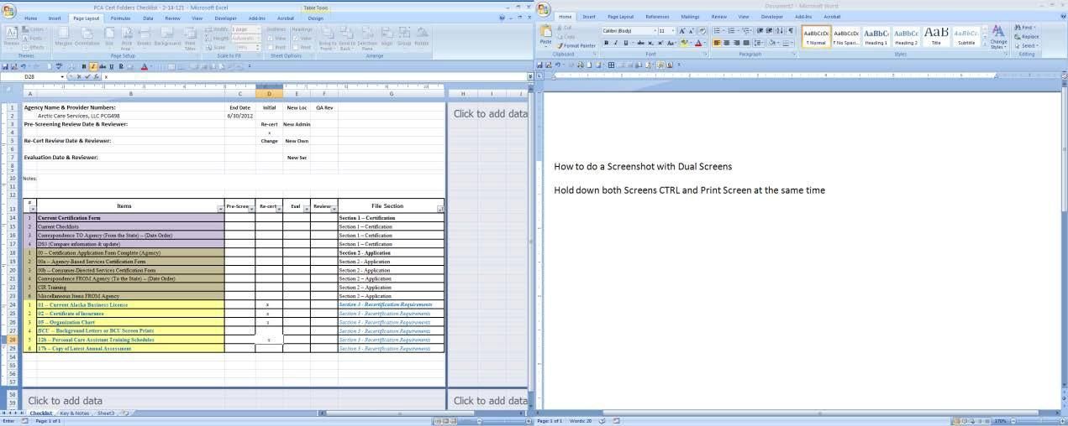

Paste into Word or Outlook E-mail using CTRL-V Active Window ONLY

Hold down CTRL-ALT and Print Screen

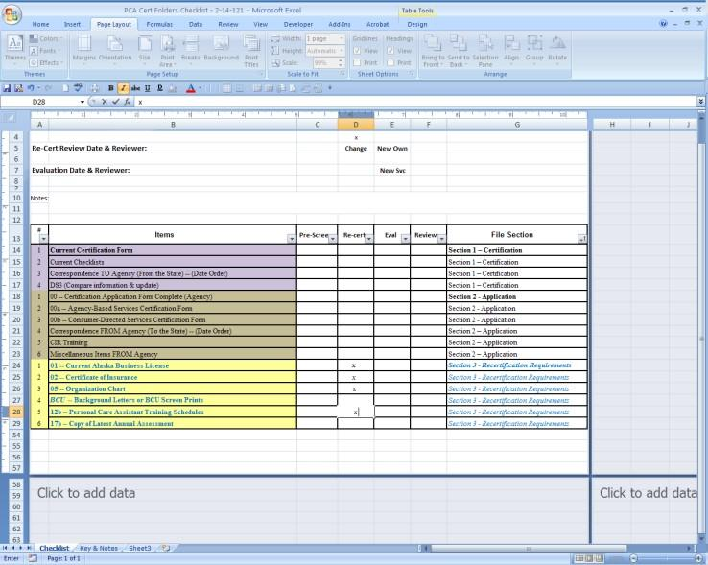

Paste into Word or Outlook E-mail using CTRL-V

**Editing or cropping pictures & screenshots**

Focusing on a ToolBar or smaller detail requires a little bit of editing both Word and Outlook can do this and do it the same way.

Click the picture to get the Handles around the outside.

Go to Picture Tools > Format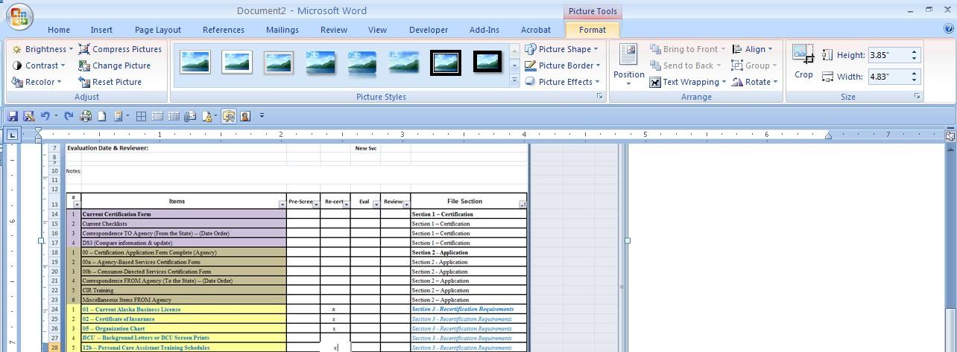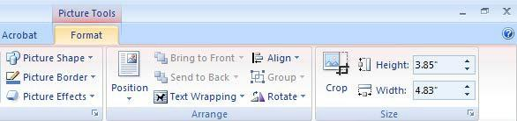

The Crop tool will allow you to cut the size of the picture down so you can focus on just what you need To add Circles or Arrows with comments go to Insert > Shapes and pick what you need.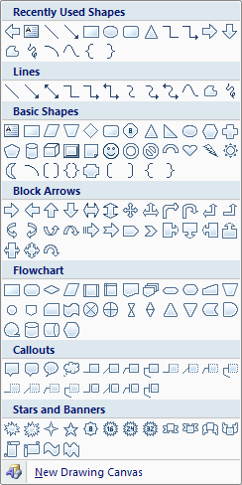

Change the color and size with the Drawing Tools or Text Box Tools Menus depending on the shape you used.

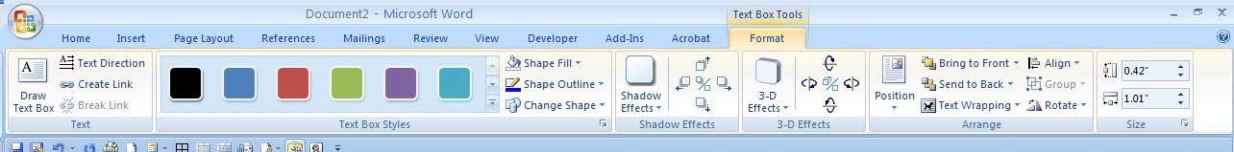

**Other Non-Certified Provider Updates**

Once a year non certified Medical Supply and Long Term Care providers need to be updated. This happens in December or early January at the latest.

* + Pull an Active Provider report
  + Sort to just non-certified providers (no start date and only ending 12/31/XX is a fair hint that they are the right ones)
  + Look up each active one in Enterprise to determine if they are still active
  + Compare basic contact information with DS3 and update as needed
  + Under Medicaid Codes change the end date to 12/31/xx (the next year)
  + If the provider is no longer active in Enterprise deactivate them in DS3

**PCA List**

The PCA List is a public list that is pulled and published monthly. The completed PDF goes to primary website maintenance liaison, who is currently Angela Salerno, for posting to website. If requested to forward to Karen Copely, the Department’s website manager, also copy Unit Manager



* + Reports Manager > Provider_Search_Tool report

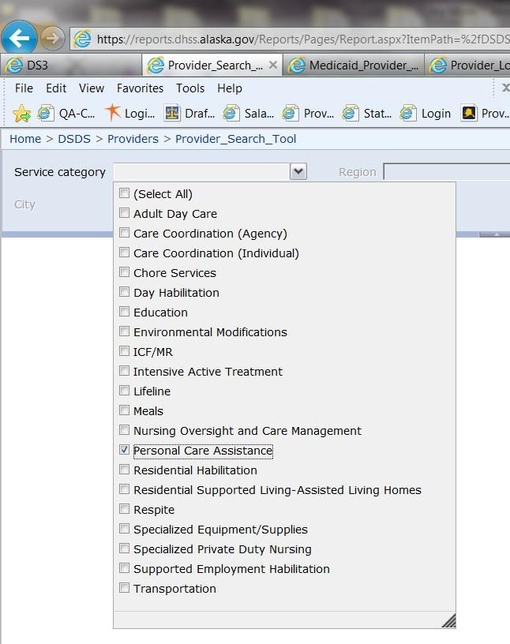

* + Service Category →Personal Care Assistance

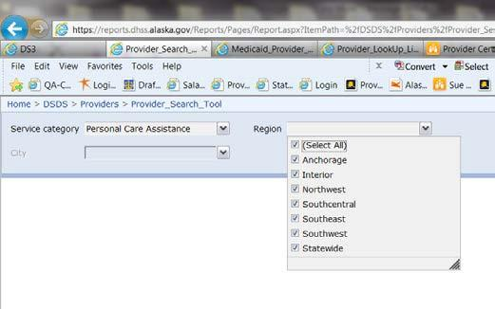

* + Region → All

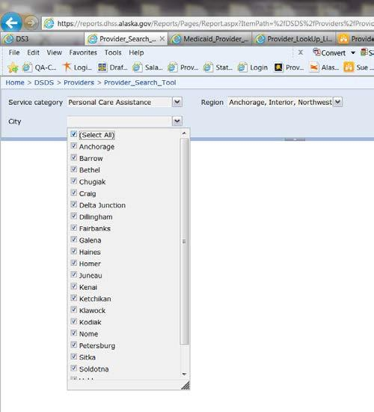

* + City → All

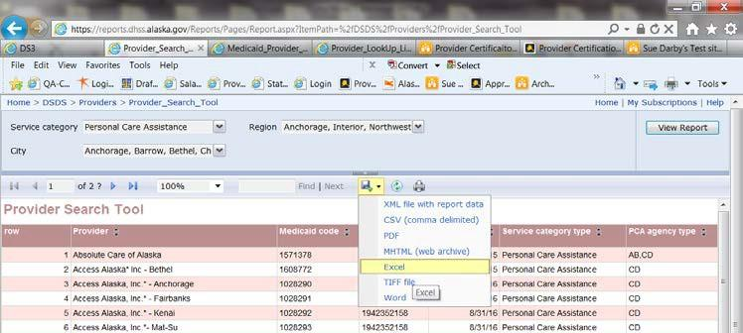

* + Report is displayed
  + Export to Excel

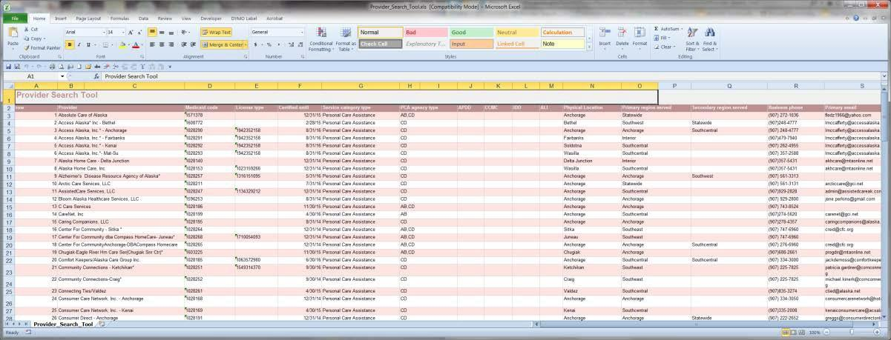

* + Generated Report

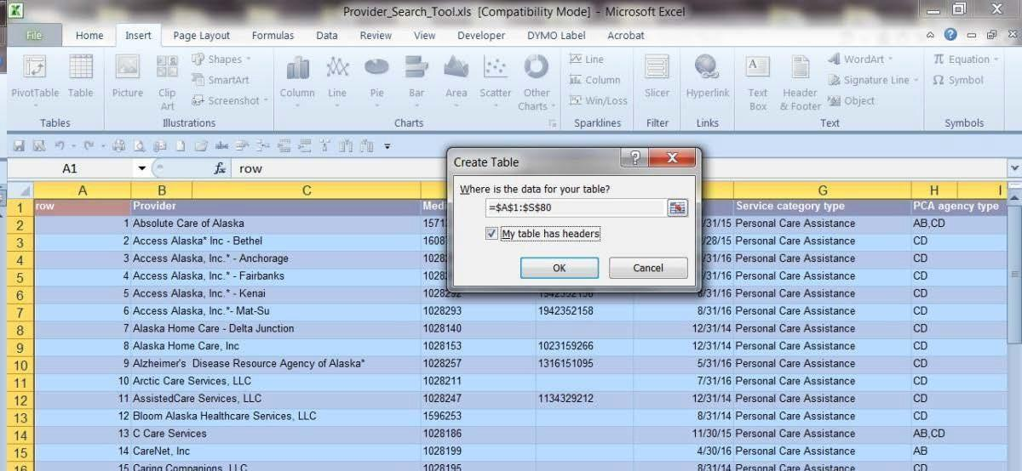

* + Convert to Table
  + While the sheet is highlighted apply a No Color Fill to change the color to blue

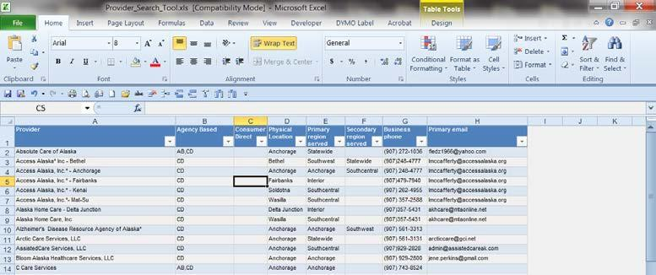

* + Delete extra Columns
  + Re-label APDD to Consumer Direct and PCA Agency Type to Agency Based

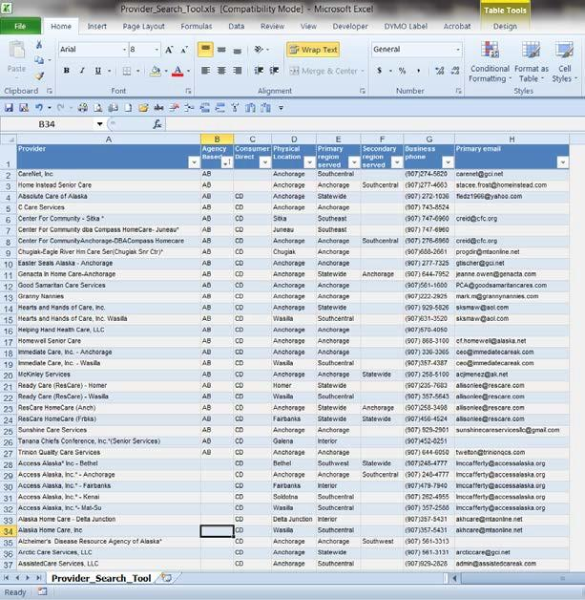

* + Sort by Agency Based A-Z
  + Separate out the Agency Based vs Consumer Directed into the second column
  + Re-alphabatize by Provider A-Z

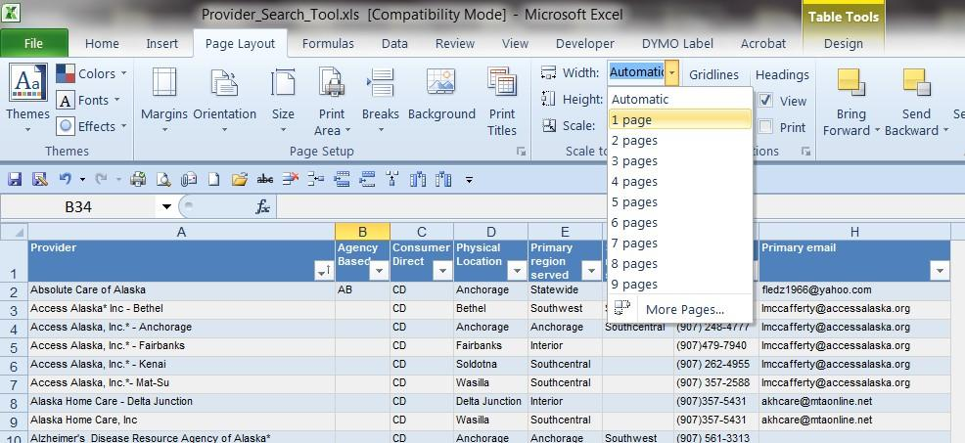

* + Go to Page Layout and change Width to 1 Page

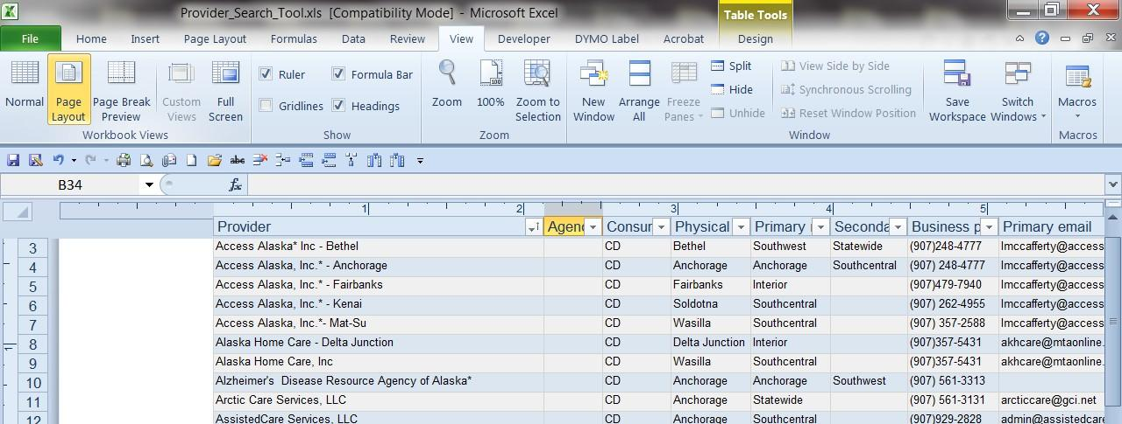



* + Go to Page Layout →Orientation → Landscape then Margins→Narrow



* + Add Page Number (type )of then Number of Pages to the left header



* + Add Current Date and Current Time to the right header

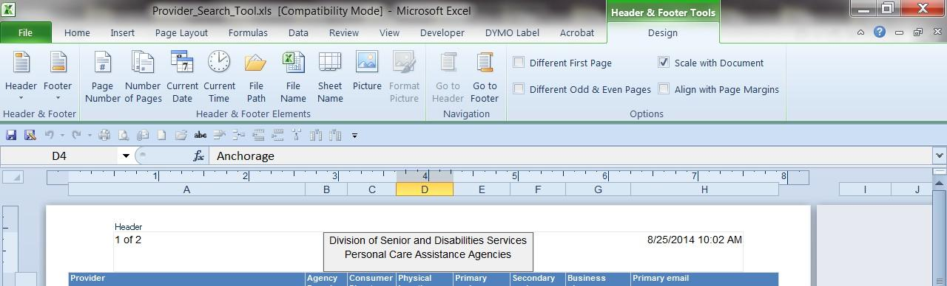

In the center section add:

Division of Senior and Disabilities Services Personal Care Assistance Agencies

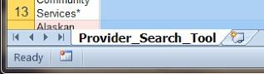

* + Right click on the sheet name and Rename it to PCA Agency List 8-2014 (or current month & year)

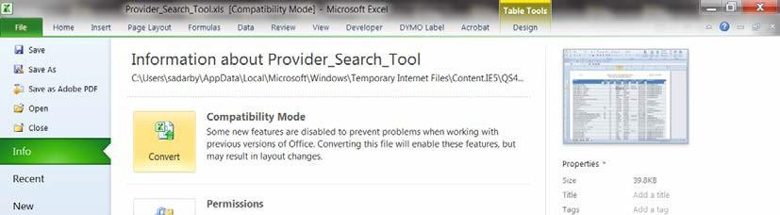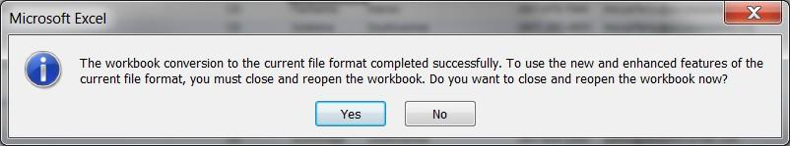

* + Go to File → Convert and click Yes

This ensures that the tweaks such as the table used is saved and makes the file format a XLSX which saves in a smaller file.

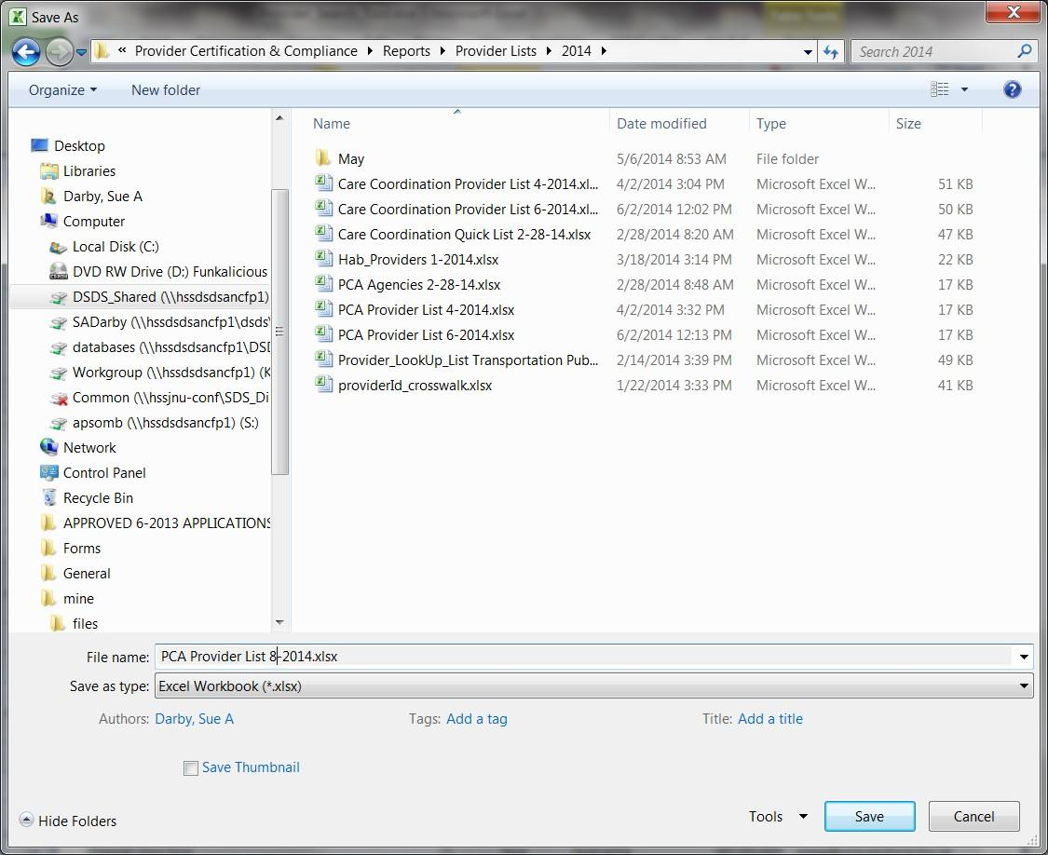

* Save in G:/Provider Certification & Compliance →Reports→Provider Lists → 2014
* Save As PCA Provider List 8-2014.xlsx

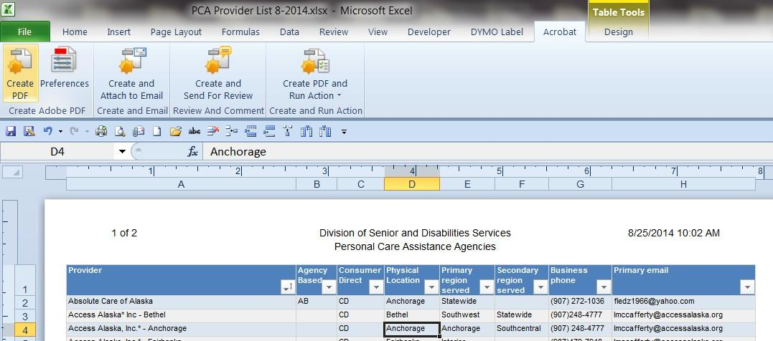

* Go to Acrobat → Create PDF



* + Click Convert to PDF

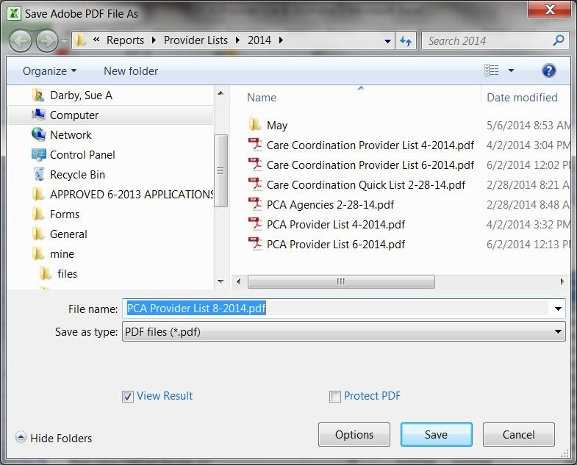

* + When Prompted SAVE!
  + PCA Agency List and Current Month-Year
  + Word & Adobe will convert the file and open it in Adobe when completed

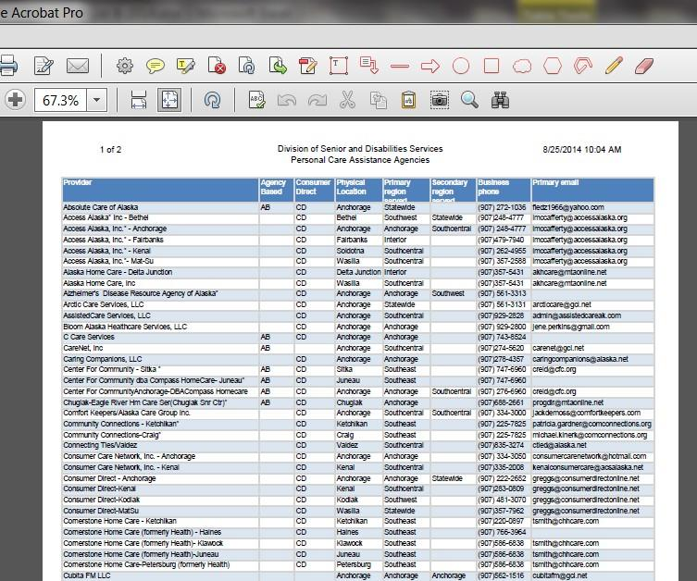

* + Completed file for posting

|  |  |  |  |  |  |
| --- | --- | --- | --- | --- | --- |
| **PROJECT & GOAL PLANNER** | | | | | |
| **Subject** | | **Date** | | | |
| **Description** | | | | | |
| **Considerations** | | | | | |
|  | | | | | |
| **Action Steps** | **Responsibility** | | **Start** | **Finish** | **Completed** |
| **1** |  | |  |  |  |
| **2** |  | |  |  |  |
| **3** |  | |  |  |  |
| **4** |  | |  |  |  |
| **5** |  | |  |  |  |
| **6** |  | |  |  |  |
| **7** |  | |  |  |  |
| **8** |  | |  |  |  |
| **9** |  | |  |  |  |
| **10** |  | |  |  |  |
| **11** |  | |  |  |  |
| **12** |  | |  |  |  |
| **13** |  | |  |  |  |
| **14** |  | |  |  |  |
| **15** |  | |  |  |  |
| **16** |  | |  |  |  |
| **17** |  | |  |  |  |
| **18** |  | |  |  |  |
| **19** |  | |  |  |  |
| **20** |  | |  |  |  |

|  |  |  |  |  |  |
| --- | --- | --- | --- | --- | --- |
| **PROJECT & GOAL PLANNER** | | | | | |
| **Subject** | | **Date** | | | |
| **Description** | | | | | |
| **Considerations** | | | | | |
|  | | | | | |
| **Action Steps** | **Responsibility** | | **Start** | **Finish** | **Completed** |
| **1** |  | |  |  |  |
| **2** |  | |  |  |  |
| **3** |  | |  |  |  |
| **4** |  | |  |  |  |
| **5** |  | |  |  |  |
| **6** |  | |  |  |  |
| **7** |  | |  |  |  |
| **8** |  | |  |  |  |
| **9** |  | |  |  |  |
| **10** |  | |  |  |  |
| **11** |  | |  |  |  |
| **12** |  | |  |  |  |
| **13** |  | |  |  |  |
| **14** |  | |  |  |  |
| **15** |  | |  |  |  |
| **16** |  | |  |  |  |
| **17** |  | |  |  |  |
| **18** |  | |  |  |  |
| **19** |  | |  |  |  |
| **20** |  | |  |  |  |

|  |  |
| --- | --- |
| D at e | P r oject : |
|  |  |
|  |  |
|  |  |
|  |  |
|  |  |
|  |  |
|  |  |
|  |  |
|  |  |
|  |  |
|  |  |
|  |  |
|  |  |
|  |  |
|  |  |
|  |  |
|  |  |
|  |  |
|  |  |
|  |  |
|  |  |

**Provider Folder Plan**

**Section 1**

* 1. Certification forms
  2. Checklist
  3. Correspondence

**Section 2**

* 1. Application forms
  2. CIR training certificate

**Section 3**

* 1. Business license
  2. Certificate of Insurance 3-3a Organizational Chart
  3. b Personnel List

3-3c BCP information 3-4 Annual Report

3-5a Current ALH license

* 1. b List of Habilitation homes
  2. a Copies of current vehicle registration 3-6b Local permits (transportation)
  3. a Food permit

3-7b 5-week menu cycle

**Section 4**

4-1 Program Administrator Appointment Form/s 4-2 Attachments

**Section 5**

* 1. Operations Manual
  2. Core employee policies
  3. Specific Service Requirements
     1. Care Coordination: Plan of Care policy/procedures; Conflict of Interest; disclosure of ownership statement
     2. Adult Day: Participant handbook; Building permit; posted emergency procedures; floor plan; ADS service plan
     3. Day Habilitation services(for unlicensed site-based ): Building or use permit and posted emergency evacuation procedures
  4. Authority to Conduct business/Ownership Documents

**Section 6**

* 1. Notices and/or adverse actions (Sanction notices, Notices to Correct, Records Requests, Other notices)

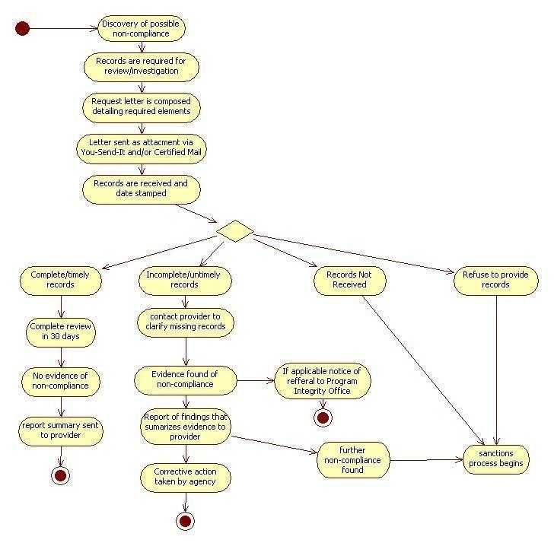

QA Provider Certification Provider Electronic Folders Processes

Updated 10-2012

* **Provider Agency Folders Naming and Organizing** in the Quality Assurance Folder of the G Drive:
  + **Main Agency Folder**: all locations and provider types owned by one agency go under main

folder (**ResCare, Access Alaska, Catholic Community, etc**) currently certified. Agency that start with “The” are named using the root name, leaving “The” at the end of the name **(Ark, LLC, The)**

* + **Sub-folders**:
    - **Location:** If a provider has more than one location, each location should have a Provider Location sub-folder listed with the agency name, and location (**Acme Agency Soldotna, Acme Agency, Wasilla**). Agency location is **OPTIONAL**, only for those with more than one location.
    - Each Provider Agency folder or Provider Location Folder may contain the following sub- folders depending on the information pertaining to the provider:
    1. **Services:** Waivers, PCA, Individual Care Coordinators (CCs) specific to location
    2. **Waivers & Variances**- maintain one folder under main folder for all locations
    3. **Reports of Investigations**-save specific to location
    4. **Audits & Reviews**-maintain one folder under main folder for all locations
    5. **DHSS Actions**-maintain one folder under main folder for all locations (Exception: denied or closed locations)
    - Information maintained within each of these folders is listed below.
    - Exceptions- will be documented at the bottom of this document
    - **Documents:**
      * **Screening Checklists:** saved in associated folder, whether initial, recert, new location, or new service.
        + Name as **“Agency Name, Service-type Checklist, Location, Date ” (Acme**

**Agency, PCGAPP Checklist, Nome, 12-2010); (Acme Agency, HC123, Soldotna, Recert Checklist , 01-2012)**

* + - * **Initial Applications Including Add-On Services and New Care Coordinators**: Scanned and saved to provider agency folder.
        + Name as **“Agency Name(location), Initial Service-type App, Location, Date**

**” (Acme Agency-Nome,, PCGAPP, 12-13-2010); (Acme Agency, Suzie Smith, CMAPP, 01-2012); (Acme Agency, HC123, ResHab-FH, 02-2012)**

*** Note: See bottom of this document to see acceptable service abbreviations

* + - * **Recertification Applications**: Scanned and saved to provider agency folder, in sub-folder for location. If more than one location, should be sub-folders named for each location.
        + Name as: **“Agency Name-(Location), Provider #, Recert, Date” (Acme**

**Agency-Soldotna, HC123, Recert, 01-2012)**

QA Provider Certification Provider Electronic Folders Processes

Updated 10-2012

* + - * **Cert Forms:** saved in the appropriate folder or subfolder. For Cert Forms only, the date of the document will align with the end date of that certification. Acceptable names:

→ Initial: Acme Agency-Anc,HCAPP,InitialCertForm,01-31-2012

→ Initial App Denied: Acme Agency-Anc,HCD,InitialCertForm,01-31-2012

→ Initial App Withdrawn: Acme Agency-Anc,HCW,InitialCertForm,01-31-2012

→ Initial App Cert/Not Enrolled: Acme Agency-Anc,HCX,InitialCertForm,01-31-2012

→ Recertification: Acme Agency-Anc,HC123,RecertForm,01-31-2013

→ Extended Certification: Acme Agency-Anc,HC123,ExtCertForm,03-31-2013

→ Corrected Certification: Acme Agency-Anc,HC123,CorrectCertForm,03-31-2014

→ Ended Certification: Acme Agency-Anc,HC123,EndCertForm,01-31-2014

* + - **Services:** if the agency provides both waivers and PCA, there should be subfolders for each service, at each location. Whenever a new service category (CMG, HC, RL, EM, PCG) is added by an agency, a subfolder is created either in the main agency or in the location folder. Name them **(Acme Agency-Wasilla-PCA, Acme Agency-Anchorage-Waiver Services).**
* **Documents: Use same naming process under location documents above.**
* **Care Coordination:** If there is multiple care coordinators certified under one agency, a sub-folder/s maybe created and named **“Agency Name**, **Individual CCs Certified” (Acme Agency, Individual CC Certified). If the agency is even larger, additional sub-folders maybe created and named “Acme Agency, Individual CCs Certified 2011)**
  + **Individual Care Coordinators**: Initial application packets and associated documents scan to the provider agency folder and name: **“Agency Name, CC Name, CMX, Date of App” (Acme Agency, Snow White, CMX, 01-2012).** If there is a sub-folder named **“Individual CC Certified in 2012”** then it should be saved in that folder. If there is an **“Acme Agency CMG folder”** save it there. If there is no separate folder labeled either CC or CMG, save out in main folder.
    - **Waivers & Variances:** Name a sub-folder **(Acme Agency Waivers & Variances);** additional sub-folders created as needed and named **“Name of Agency, CPR Waivers, date” (Acme Agency CPR Waivers, 2012) and “Name of Agency, Variances, date” (Acme Agency Variances, 2012).**
* **Documents:**
  + **CPR/First Aid Waivers**: Save all waivers for that provider in that sub-folder. Name the scanned document: “**CPR, Agency Name, Last Name, First Initial, (month-year)” (CPR, Acme Agency, Smith, R. 01-2012)**

QA Provider Certification Provider Electronic Folders Processes

Updated 10-2012

* + **Variances:** When staff processes a variance for an agency, that staff will place a link into that agency folder to the “Variance Log”.
    - **Reports of Investigation:** subfolder created as soon as reports are to be saved as **“Agency Name, ROI”.** Other subfolders may be created for additional locations or years.

o **Documents:** Saved as named by ALH Licensing.

* + - **Audits & Reviews:** subfolder to be named **“Agency Name, Provider #, Audits & Reviews: (Acme Agency, HC123, Audits & Reviews)**
* **Documents:**
  + **Site Reviews** : Name and save file as “**Agency Name, Provider #, Site Review, date” (Acme, HC123, Site Review, 01-2012)**
  + **Audit Reports:** Create a subfolder if needed as “**Audit Reports**” and name and save document as **“Acme Agency, Audit, 01-2012”.**
    - **DHSS Actions: Name as “Agency Name, DHSS Actions” (Acme Agency, DHSS Actions)**
* **Documents:**
  + **Formal Correspondence (Letters):** The documents should be named **“Agency Name, Provider #, Name of document, date” (Acme Agency, HC123, Invitation to Recertify, 01-2012).**
  + **Records Requests** should be named as **“Agency Name, Provider #, Records Request, date” (Acme Agency, HC123, Chore Services Records Request, 01-2012)** Include copy of original request as part of scanned document.
  + **Investigation Reports:** The documents should be named **“Agency Name, Provider #, Investigation, date”: (Acme Agency, RL000, Fraud Investigation, 01-2012).**

Acceptable Service Abbreviations:

→ Care Coordination Services (CMG)

→ Residential Habilitation Services (ResHab)

→ Day Habilitation Services (DayHab)

→ Supported Employment Habilitation Services (SupEmpHab)

→ Adult Day Services (AduDay)

→ Residential Supported Living Services (RSL)

→ Respite Services (Resp)

→ Intensive Active Treatment Services (IAT)

→ Environmental Modification Services (Emod)

→ Chore Services (Chor)

→ Transportation Services (Trans)

→ Meal Services (Meal)

QA Provider Certification Provider Electronic Folders Processes

Updated 10-2012

* + **1-A CLOSED PROVIDER AGENCY FOLDERS**: All closed agency folders shall be placed here after all correspondence and actions have been completed and packet has been scanned and saved, by the SDS staff person handling the closure.
  + **1-A DENIED OR WITHDRAWN APPLICATIONS:** All agency folders where the application was

denied or withdrawn shall be placed here, by the staff person handling the action, after all correspondence and scanning of documents are completed.

* + - **Documents:** All incomplete, denied or withdrawn applications are saved in the root-agency (primary) folder as follows”
* Incomplete Applications:
  + Letter saved as **“Agency-name(location), App Type, incomplete, date .docx (Acme Agency-Frbks, HCAPP, Incomplete, 02-2012.docx)**
  + Application is scanned and saved same as letter above, with .pdf extension
* Denied Applications:
  + Letter saved as **“Agency-name(Location), App Type, date .docx (Acme Agency- Kodiak, HCD, 02-2012.docx)**
  + Application is scanned and saved same as letter above, with .pdf extension
* Withdrawn Applications:
  + Letter saved as **“Agency-name(Location), App Type, date .docx (Acme Agency-Anc, HCW, 02-2012.docx)**
  + Application is scanned and saved same as letter above, with .pdf extension

**Re-Certification Folder Process HCB Blue folders**

* **Section 1:** Keep all certification forms in the file. Any old correspondence and checklists get pulled out.
* **Section 2:** Pull all information out for off-storage. Exception: Keep the CIR training certificate in the file if it was not re-submitted.
* **Section 3:** Pull all information out for off-storage. Keep tabs for re-use.
* **Section 4:** Only remove the Program Administrator information if there has been a change to this information. If it is the same PA keep the information in the file.
* **Section 5:** Only remove the policies that have been updated and replace with current policies. Otherwise, keep this information in the file.
* **Section 6:** This is permanent information so do not remove. Please note that is Section 6.2 there may be information/policies that were submitted during a compliance review that needs to be incorporated into the file.

SST folders and updates site based Residential Habilitation providers. Please put each home’s license in the order it is listed on the site form and place in section 3-5.

**Care Coordination Folders**

The materials in these folder is not moved around except in the rare case that the folder is too full then it is processed for offsite storage. Otherwise do the following:

* **Left side:** Current materials on top Certification form, check list, application, and BCU form
* **Right side:** Training, education and resume
* Materials should be oldest on bottom to newest on top
* If the label for the file has a CM number or CMX replace the label with the correct format

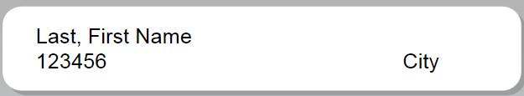

**PCA Folders**

PCA Folders are similar to HCB Folders in setup and archive materials as follows:

* **Section 1:** Keep all certification forms, old correspondence and checklists move to offsite
* **Section 2:** remove old application form, only keep CIR Certificate if new one has not been submitted
* **Section 3:** remove everything as new materials should have been submitted during recertification. Keep tabs for re-use
* **Section 4:** only remove policies that have been updated
* **Section 5:** only remove information that has been updated
* **Section 6:** never remove

The materials pulled out of the folder should be placed in a manila folder and labeled as follows to show the Agency Name, Provider #, Physical City of Agency, and Current certification period you are archiving.

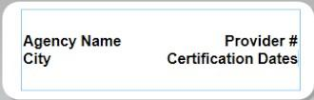 or 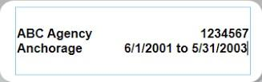

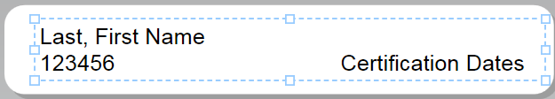 for Care Coordinators

**Recertification Process**

Invitation to Recertify

Letter 120 days before recert (start June 1) 30 day deadline (due date 90 days before cert end) (Regular Mail)

App rec’d

No=2nd notice w/10 day deadline (certified) (email copy?)

No after 10 day deadline = 3rd notice “60 day notice” w/ 5 day deadline (certified) (email copy?)

No after 3rd notice/5 day deadline = inform clients & programs w/ e-mail return receipt, DS3 notes & start closure process

Closure = DS3 edits, Xerox work order, notify programs Yes = screening within 2 weeks

Incomplete = e-mailed list of missing items and moved to evaluation w/ 10 day deadline Complete = moved to evaluation

Evaluation

Request add’l info = 10 day deadline Info not rec’d see “No” above

Rec’d

Complete Recertified

Documents changed in folder Old sent to offsite storage

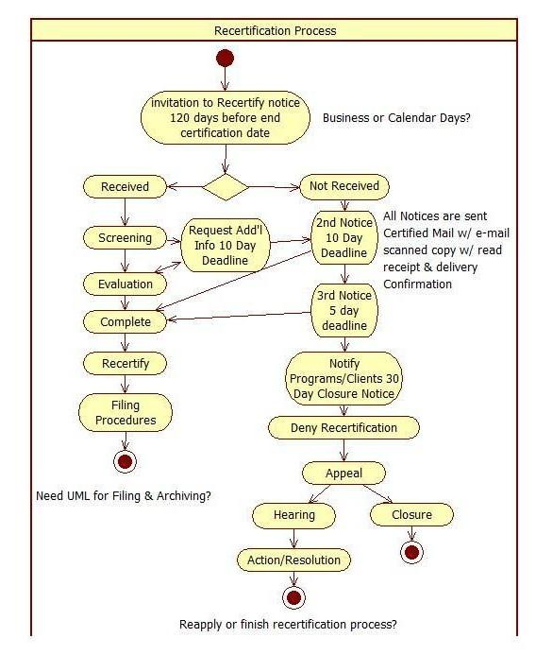

Requesting from Archive

Go to Archives site <https://go.dhss.ak.local/dsds/archive/SitePages/Home.aspx>

Go to Archived Files

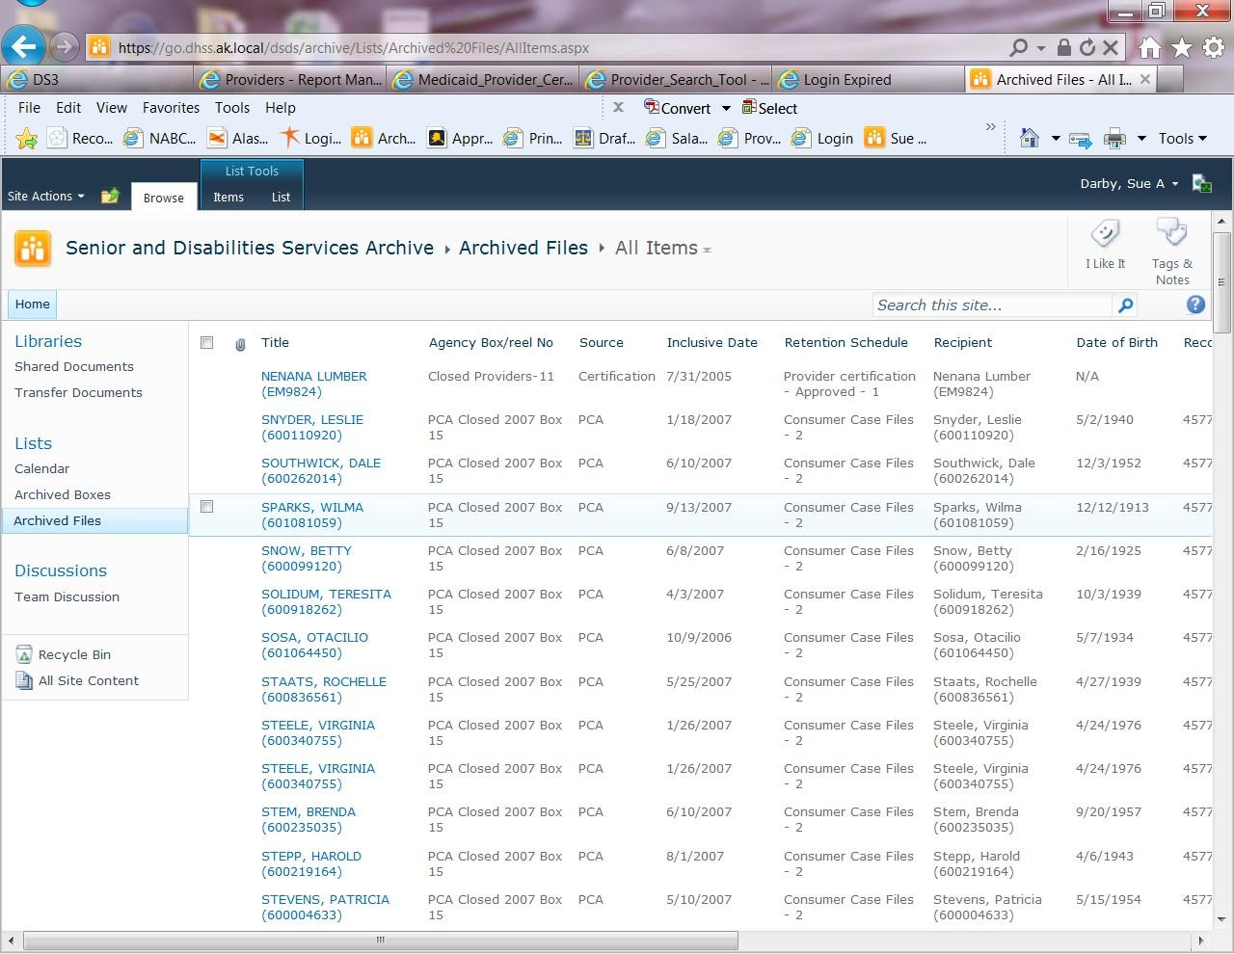

Search by provider number. If it is an older provider you can try the new number but if nothing is found check older numbers

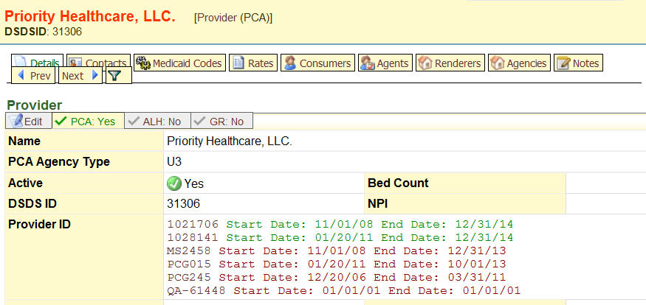

A good hint there is *something* in archives is to check the notes for ones that look like this:

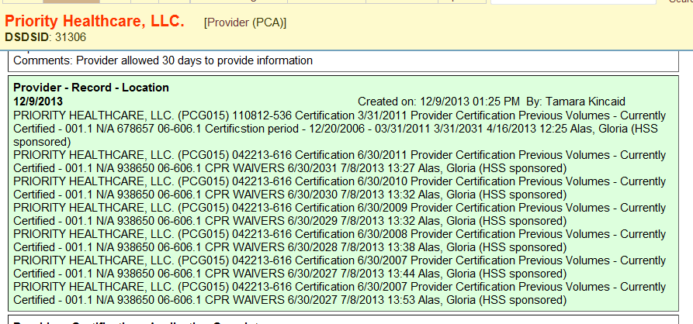

This can give clues to which number to search the Archive site with. When you search you should get a list of results like this:

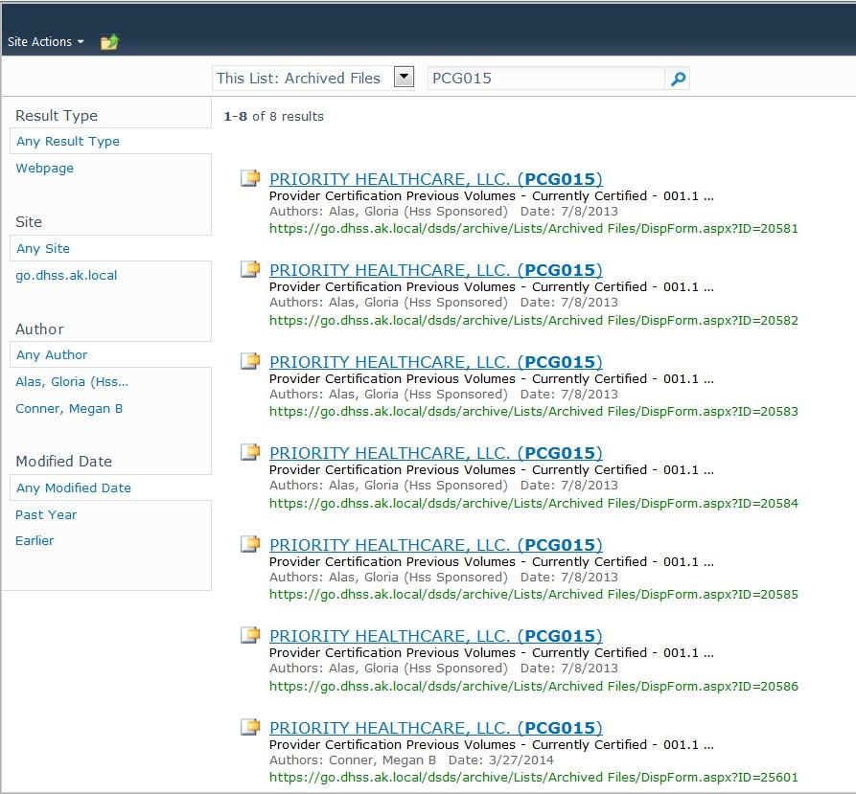

Each link above is one folder of information. Click on each one and usually there are notes as to what the file contains. Sometimes it is a certificaiton file and other times it is other information depending on the age of the provider.

To request a file from archives go into the result of choice:

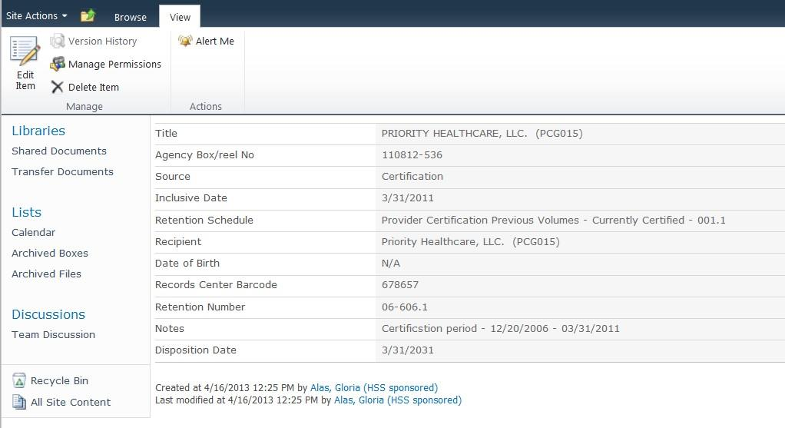

Copy and paste the following into an email to Tim Barnes or whomever is the Administrative Manager. Delete extra rows until you have the following information:

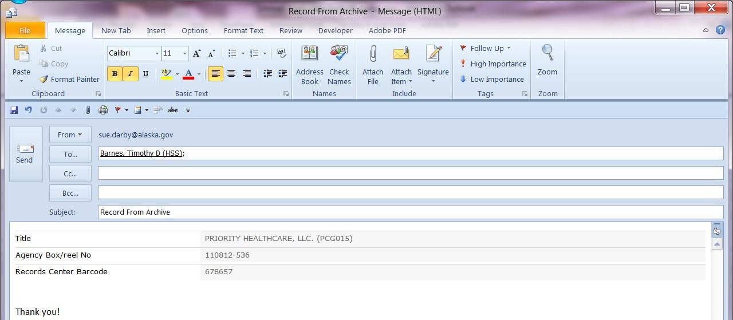

Archives does not want or need the rest of it. Add a simple note asking Tim to request the file ASAP and shortly afterwards you should get a confirmation back from him that it is ordered and then another phone call or email when it comes to the front desk.

Returning a file is easy, email Tim that you have files to go back and take them to the front desk for pick up.

|  |
| --- |
| [**From Evernote:**](http://evernote.com/) |
| **What I do for QA** |

Write up process or details of tasks listed

Email distribution QA box Cert box Mail distribution

BCU lookup in MMIS for PC numbers Date stamp

Record requests CPR FA waivers Meeting setup Equipment setup

Equipment maintenance copier fax

User troubleshooting for office programs Adobe pro

Train volunteers Delegate tasks

Track screenings due dates

Outgoing mail including sensitive materials and certified

Convinced other state agencies to allow scanned records requests to reduce wear on machines, paper, ink and jamming in addition to cost of shipping

Business cards Labels

Tags

Project trackers until formal tools are developed Meeting minutes

UML diagrams

Power point presentations Open & pri.t oddfile formats Track incoming recerts & I.itials Order supplies

Physical drawer space manavement Assist w/ dev of electronic file system Tutorials for tricks to streamline processes Mass mailings

Consult a Ra team for report building

Encouraged sr mgrs to sign a mou for MASST DVR volunteer programs Interview. Coordination

MMIS EIS DS3

Contact lists for unit

Build new shared tracking tools until new systems can come online Form redesign

Adobe workflow setup

Report design and testing Harmony User testing Harmony

Edit and program in VB.Net checklist and tab divider generator Edit and maintain 46 application forms

built CPR waiver tracker

run reports from application tracker built application tracker

maintain enough supplies to ensure unit/division made it through buying freeze mail merge envelopes for large mail outs instead of labels saving $$

provide technical assistance on multiple certification topics process CPR Waivers

update old procedures with screen shots write multiple procedures

provide archives training to new Admin staff

turned Word based Applications into PDF fill in forms for Certification and website train QA on use of Adobe Pro for Bates stamping for hearing paperwork

pend letter is a template 8/7/15

organized back files of certifications into binders

new printer configuration coordination end of July 2015 multiple large mail outs for QA

facilitate date stamper sent for repair

desk review tool completed 9 ‐15‐ 15

configured desktop printer as temporary fax machine while printer was down

Completed process of making Archive sharepoint CALCULATE retention CORRECTLY and generate a report CORRECTLY

compilation of ALL processes into comprehensive procedure manual from start to finish for certification including small side procedures and helpful tools

certificaiton box working for team 7/29/15

AdobePro used as workaround for date stamper while down Admin for Archive sharepoint

500++ record merges for DS3 as of 9/2015 24 boxes of archives send in August 2015

user friendly regulations for management and website 8 ‐15‐ 15

updated code on checklist 9/1/15

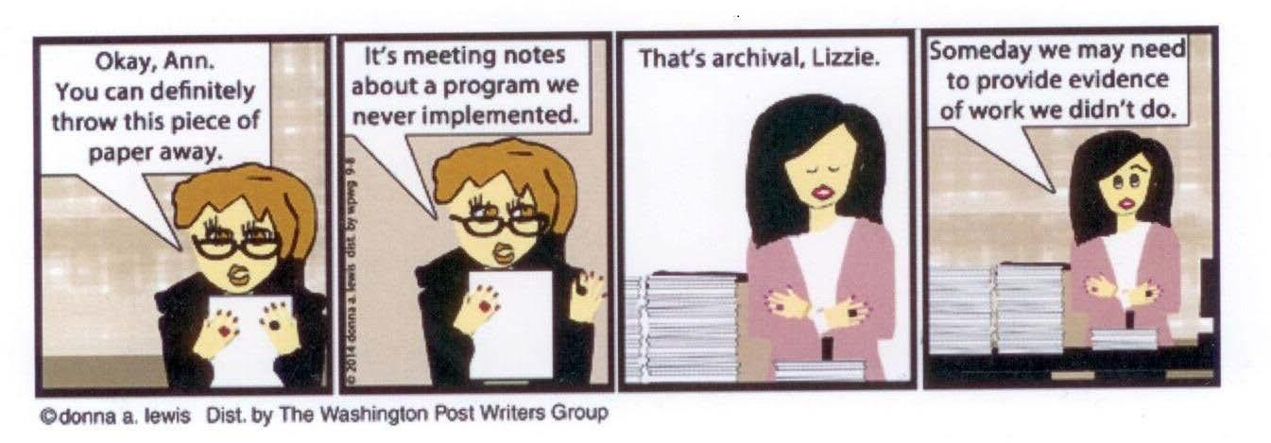

**Okay, Ann. Its meeting notes Thats archival, Lizzie. Someday we may need You can definitely about a program we to provide evidence throw this piece of never implemented. of work we didnt do.**

**paper away.**

©donna a lewis Dist, by The Washington Postwriters Group

Archiving

As a business there comes a time when you run out of space for paperwork or electronic files. This is when you need to make decisions about what to keep and what to get rid of. Hopefully you already have a policy and even a procedure to make the process less painful.

Electronic files if they are organized well can be backed up to another hard drive or other media. In fact your electronic files should be backed up on a regular basis. Some ideas for regular back ups might be to use an online system in addition to on site back ups. While this might be a pain to setup initially it will be worth the effort when a hard drive fails.

Archiving File Types and How to Categorize them for Archiving or Off Site Storage 6-2013

**Archiving File Types and How to Categorize for Archiving or Off Site Storage Definitions**

**Archive –** closed providers ONLY includes the provider file and any additional files related to the provider can be Voluntary or Involuntary closures with Auxiliary files such as reports and investigations or site reviews and BCU Variances along with CPR Waivers

**Off Site Storage –** Open Volumes for ACTIVE providers include the previous certification period and any additional materials but NOT the materials that are kept ON SITE for the current certification period. There are no auxiliary files for OPEN Volumes.

**Open Providers - *Provider Certification Previous Volumes – Currently Certified 001.1***

**Current Active Providers** have 1 certification period stored on site (the current Certification period) the remainder of paperwork from previous certification periods is stored in *Off Site Storage* and is entered under ***Provider Certification Previous Volumes – Currently Certified 001.1*** by their **ACTIVE** provider numbers. IF the agency has had a change of numbers due to ownership or business changes or a lapse in Certification enter under the **OPEN** number or the Number on the file. There are exceptions made on a case by case basis, based on the provider i.e. if the business is sold to a new owner but keeps the name of the business the same, then the old materials are archived under the CLOSED provider number while the new owner would have their materials eventually sent off site under the NEW provider number.

**Off Site Storage of Non-Core-Certification Files**

**Audits**

APS Audits, RAC, M&S etc

**Open Audits**

* Open Volumes
* Voluntary Closure Auxiliary files
* Involuntary Closure Auxiliary files

**Inclusive Date**

* Audit Completion date for Open providers
* Provider end date for all closed files

**Notes**

* APS Healthcare Audit Final Report date xx/xx/xxxx
* M&S Audit Final Report date xx/xx/xxxx

**BCU Variances Name**

* Provider Name
* Closest city on application for multi-site agencies

Archiving File Types and How to Categorize for Archiving or Off Site Storage 6-2013

Archiving File Types and How to Categorize them for Archiving or Off Site Storage 6-2013

* + Provider number if available

**Dates**

* + Barrier end date
  + Variance end date

**Notes**

* + Entered under one provider or many providers
  + Note if there is more than one provider that the individual is working for
  + More than one variance or a continuance

**CPR Waivers Name**

* + Provider Name/Location of Main Office (Anchorage, Juneau, Fairbanks etc)/Number

**Inclusive Date**

* + Grouped together by fiscal year

**Closed Provider Files**

**Criteria for Involuntary Closed files – Must be approved for entry and transfer by manager**

* + Sanctions
  + Negative actions

**Criteria for Voluntary Closure**

* + Give up ALH License
  + Notify SDS of closure
  + Notify SDS not recertifying
  + Do not recertify but do not notify SDS

**Investigation or Abandoned Provider Records Archived as Auxiliary Files Name**

* + Provider Name & Number

**Inclusive Date**

* + Latest date found in file
  + Flag page the date is found on

**Open**

* + Send Off-Site as Open Volume

**Closed**

* + Voluntary Auxiliary file
  + Involuntary must be approved by manager

**Labels**



Provider Name

APS Healthcare Audit

Provider Numbers

Date from NEWEST letter

Provider Name

BCU Variance

Provider Numbers

Variance End Date

Archiving File Types and How to Categorize for Archiving or Off Site Storage 6-2013

Archiving File Types and How to Categorize them for Archiving or Off Site Storage 6-2013 Provider Name Provider Numbers

CPR Waivers Date

Provider Name Provider Numbers

City Date

Each folder may have other labels on the second line such as Sanction Actions, Investigation, Client Name (for abandoned files). Each file will have a second label indicating the retention schedule it is filed under.

Each folder will have on the body of the folder a sticker indicating retention schedule the file is to be entered under. ALL the files in a box MUST be the same!

Provider Certification Previous Volumes Currently Certified 001.1



Voluntary Closure

001.2 – Provider Certification

**Steps of Conversion**

**Hard Files**

Check status open or closed, if closed determine voluntary or involuntary & set aside

Place completion or newest letter on top of pile for first 2 sections of multi file and stack on left side of soft file folder, take section 3 and pile it on section 4. If file is oversize break into 2 folders distributing documents as needed and labeling identically to first folder

**Conversion for Re-Certifications Closed Files**

**Voluntary Closure - 001.2 – Provider Certification (Voluntary Closure)**

The business has decided to close or the provider has decided to no longer serve Medicaid clients. This should be the main certification file and any historic file documentation. If it is found at time of closure and archive entry this may include investigations, complaints, site reviews etc.

Archiving File Types and How to Categorize them for Archiving or Off Site Storage 6-2013

**Certified But Never Enrolled** (HCX-NE etc.)

These are certified providers who completed the process of certification but did NOT enroll with First Health, ACS or Xerox for some reason and are thus classified as ***Provider Certification – Closed 001.2***

* 1. **– Provider Certification (Auxiliary Files – Voluntary Closure)** Audits, Reviews, Complaints, Corrective Action Files, Additional materials found after archive of main folder (not part of main provider folder)

**Involuntary Closure**

* 1. **– Provider Certification Closed (Involuntary Closure)**

Certified providers who are under sanctions or have had other negative actions by the state forcing the closure of the provider i.e. ALH License is revoked

* 1. **– Provider Certification Closed (Auxiliary Files – Involuntary Closure)**

Audits, Reviews, Complaints, Corrective Action Files, Additional materials found after archive of main folder (not part of main provider folder)

**DO NOT ARCHIVE**

Actions such as lawsuits and sanctions are still pending. These files will not go off site until all actions have resolved. They will reside in the bottom drawer of the hall file cabinet or a manager’s office. There needs to be a File Location note in DS3.

***DS3 Notes for Archiving:***

**Open Provider Certification---Previous Volume Files** (Cert History; Complaints; Audits; any auxiliary)

Ds3 notes: “Box Number _ ” “Barcode _ ” describe cert file or complaint file; site review; etc. Sharepoint notes: Describe cert file or complaint file; QA review; etc. and start end dates

**Closed Provider Certification – Voluntary 7 Year**

Ds3 notes: “Box Number _ ” “Barcode _ ” describe cert file or complaint file; site review; etc. Sharepoint notes: Describe cert file or complaint file; QA review; etc. and start/end dates

**Closed Provider Certification – Involuntary 10 Year**

Ds3 notes: “Box Number _ ” “Barcode _ ” describe cert file or complaint file; site review; etc.

Archiving File Types and How to Categorize them for Archiving or Off Site Storage 6-2013 Sharepoint notes: Describe cert file or complaint file; QA review; etc. and start/end dates

**Note:** the easiest way to do the DS3 notes is by running a report from SharePoint, exporting to Excel and sorting it by provider then copying the data from Excel to DS3.

**Voluntary & Involuntary Closure Archive Procedure 6-2013**

* + 1. Check DS3 by the provider number
    2. Red numbers on the Main page indicate closed
    3. Click a provider number to go to the Medicaid status page to find out what the closure status is set to
    4. If it is Voluntary closure enter in SharePoint under 001.2 Voluntary Closure
    5. If it is INVOLUNTARY Closure then set aside for later processing
    6. Individual Care Coordinators (CM) are found under Individual Provider not Agency but may share the same box with agency files.

**CPR Waivers**

1. Separate each provider by fiscal year July 1 thru June 30
2. Look up each provider and record PCG number from DS3. Multi-site agencies should use a main office such as Anchorage, Fairbanks or Juneau etc. (Note) July 1, 2013 a new form is in use which will list the provider number and thus waivers can be separated by location in future archiving batches.
3. Use the END of the Fiscal year for the Inclusive date on the label.
4. Label format is as above under Labels

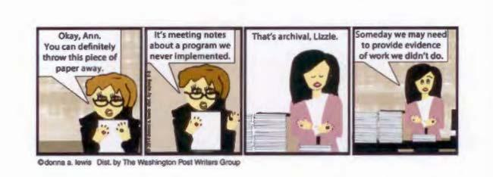

It' s Okay, Ann.

never [ implemented.

=TM""'=

meeting notes You can definitety abourt a program we throw this piece of

·Cdonna a. le wis Ois t. by TM Wasflingtoo Posl Writers Group

That's archival. Lizzie. Someday we may need

I

of to work provide we evidence didn't do.

**Business Procedure Mailing documents from SDS**

**April 12, 2013**

**Standard Mail**

Plain outgoing mail does not need a task card unless it needs to be ATTN: someone

**Certified mail**

Print the certified mail number on the green slip onto the top of the letter above the date (typed looks more professional and is more legible for litigation)

Put your *initials* on the back of the both green cards so that they can be matched when the receipts come back to SDS Complete a task card, written in pencil that tells clerical staff what to do with this document

Attach both pieces of the green card to the letter with the task card

If the document needs to be scanned before mailing, place in the *SCAN BEFORE MAILING* basket If you have already scanned the document, simply place it in the *MAIL* basket

**Wall Pockets**

*There is a mail wall pocket on the 2nd floor near the mail baskets. Mail will be delivered to 3rd floor when possible, but we can all assist with keeping things flowing*

3rd floor QA: Please check the “Upstairs” pocket for mail when you are on 2nd floor, as the 2nd floor does for faxes on 3rd floor

Leave the folders if/when you take mail to help deliver please All other pockets are labeled for individuals on 2nd floor

**Green Cards & Receipts**

As the receipts and green cards come back they will go in the” Green Card” basket to be matched. The matched cards & receipts are then placed in the “Single Documents to Be Filed” Basket in the hallway. They will be filed into the provider hard copy folder, not scanned.

IF you want your green cards back please let clerical staff know. A list of people who want the cards back will be kept in the basket with the cards so that matched cards can go into the appropriate mail pocket.

**DS3 Provider “Notes” and Definitions**

**Drop down menu**

* **Provider- App received:** Applicant has submitted an initial, renewal, or additional service application. Enter date received by DSDS in date field and indicate the type of application and services in text box.
* **Provider- App complete-** Application is signed and has all required attachments**.** Enter date in date field once application is complete. Indicate in text box the name of staff application is forwarded to and other applicable information.
* **Provider-Audit/overpayment finding**: Other state partner has issued notice that provider must reimburse the state of Alaska. Enter date issued to provider in date field and briefly describe the audit findings, amount owed, subsequent action(s), etc.
* **Provider- BCU variance:** Provider has been granted a background check variance. Enter in date field the effective date of variance. Enter: end date of variance, Provider #, individual’s name and barrier end date in text box. Add brief notes of any conditions, etc. regarding the variance if applicable.
* **Provider- CC Training:** Provider has attended DSDS required Care Coordination training. Enter date of training in date field and other applicable notes in text box.
* **Provider- CIR Training:** Provider has attended Critical Incident Report training.

Enter date of training in date field and other applicable notes in text box.

* **Provider-Certification not compliant:** Substantiated that a provider does not meet certification requirements through a discovery made from critical incident or complaint investigation, onsite review, evaluation of renewal application, or other information received by the Department. This note category *does not* include applicant that is not currently certified. Record date of substantiation in date field and enter requirement(s) not met in text box.
* **Provider- contact**: DSDS has contacted the provider or provider has contacted DSDS (examples; technical assistance, general concerns/question, clarification

of requirement, resource need, etc.) Enter date of contact in date field and briefly describe contact method, issue and outcome in text field.

* **Provider- Corrective action complete:** Provider has provided evidence corrected action was taken and requirement(s) is met. Enter date in date field that evidence was provided to Department. Enter correction made in text box along with any other applicable information.
* **Provider-CPR-FA Waiver:** Provider has been granted a waiver of this requirement for an individual PCA staff. Note effective date of waiver in date field. Enter individual, city or town, and end date of waiver in text box and other applicable information.
* **Provider-Information requested for app evaluation:** Application is complete but applicant did not have the elements needed to evaluate or make determination that certification requirements are met, prompting a request for more information. Enter date requested in date field. Briefly describe requested items in text box, method of contact and due date to submit items or information
* **Provider- Issued notice of denial or other sanction:** Provider was issued notice to deny initial application, deny renewal of certification, terminate, suspend or other sanction described in 7AAC 105.410. Record date of notice in date field. Record in text box brief description of the violation, specific sanction and appeal period end date.
* **Provider- Issued notice to correct:** Provider issued report of findings, email, or other written correspondence requesting correction and a timeline to correct. Record date sent to provider in date field. This note category *does not* include applicant that is not currently certified. Describe briefly in text box, the method of notice, correction needed, date due and confirmation that provider received notice. Emails may be copied into text box.
* **Provider-Issued notice of incomplete app:** Initial or renewal application was determined to be incomplete and applicant was sent written request to submit items and given due date. Enter date notice sent in date field and describe needed items and due date or may copy and paste email in text.box.
* **Provider-New ALH license issued:** Assisted Living licensing program issued a new or modified license that is either provisional or biennial status. The license may have had a condition placed on the license as part of an enforcement action.

.

* **Provider-PCA Training**: Administrator of PCA agency has attended DSDS regulatory required training. Note of date of attendance in date field and in text identify the trainee
* **Provider-Report of Inspection issued:** Assisted Living licensing program completed an annual or renewal inspection and issued a notice of violations if requirements were not met. The notice may also include enforcement actions if applicable.
* **Provider-RSL Training:** Administrator/Owner has attended DSDS training specific to Residential Supported Living Service. Note of date of attendance in date field and in text identify the trainee

**Copier Jammed or Just NOT Working?**

**Go find Sue, Sera or Gayle O!!!**

ARRRRRRRRGGGGGGHH!!!

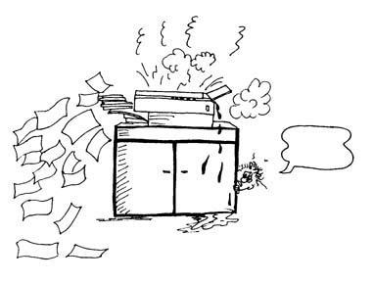

Post Matrix

|  |  |  |  |  |  |  |
| --- | --- | --- | --- | --- | --- | --- |
| 1  Justice- Christmas Kidism-Missing Penguins  Sera-Chapter1 Sokka | 2 SAD- Battle Plan Original | 3 | 4 | 5 | 6 | 7 |
| 8 | 9 | 10 | 11 | 12 | 13 | 14 |
| 15 | 16 | 17 | 18 | 19 | 20 | 21 |
| 22 | 23 | 24 | 25 | 26 | 27 | 28 |
| 29 | 30 |  |  |  |  |  |

D at e Pr oj ect :

SAD Blog Notes

**Sue Darby, MOS Portfolio**

|  |  |  |
| --- | --- | --- |
| Awards Certifications | ILA  Resume | Cover letter |
| Add new ILP Add new awards | Recent goals Career plan | Success stories RSS feed |
| New certs New awards New ILA | Revise home page Additional links |  |

**Sue Darby, MOS Portfolio** **Main Domain**

**Writing Practice** Portfolio

|  |  |  |
| --- | --- | --- |
| Writing samples Assignments | Links to Portfolio RSS Feed |  |

**Quanista** Portfolio

|  |  |  |
| --- | --- | --- |
| Links to Portfolio  Tells tale of other characters Tells tale of other games | Tells tale of new characters Links to other game related blogs  RSS feed | Links to other game sites Affiliate programs for gaming materials |

|  |  |  |
| --- | --- | --- |
| **Interesting Tid Bits**  As often as I find items to post | **Writing Practice**  Generate a list of subjects | **Helps & Tutorials** Post macro tutorial Post any other tutorial |

**Quanista**

|  |  |  |
| --- | --- | --- |
| Exalted character D&D character | Fiction writing Affiliate income | World |

**Quanista**

|  |  |  |
| --- | --- | --- |
| Character World | Other characters Other worlds |  |

**Interesting Tid Bits**

|  |  |  |
| --- | --- | --- |
| During research on subject Post about research | House Land | Work search Politics |

**Writing Practice Helps & Tutorials Quanista**

|  |  |  |
| --- | --- | --- |
| Essays | Short articles |  |

|  |  |  |
| --- | --- | --- |
| MLA Source Citing | Term paper organization | Project planning |

|  |  |  |
| --- | --- | --- |
| Provide outgoing links Provide incoming links | Generate traffic for sites Generate income from AdSense | Generate income from affiliate program  Place to write fiction |

<http://www.sue-a-darby.com/> Professional Portfolio of Sue A. Darby

<http://www.sue-a-darby.com/professional/resume/work-experience.html> Sue Darby, MOS - Work Experience

<http://www.sue-a-darby.com/professional/resume/volunteer-work.html> Sue Darby, MOS - Volunteer Work

<http://www.sue-a-darby.com/professional/resume/business-development.html> Sue Darby, MOS - Business Development

<http://www.sue-a-darby.com/professional/resume/education-awards.html> Sue Darby, MOS - Education & Awards

<http://www.sue-a-darby.com/professional/career-mentor/cover-letter.html> Cover Letter

<http://www.sue-a-darby.com/professional/career-mentor/kris-kringle.html> Kris Kringle Example Resume

[**http://www.sue-a-darby.com/professional/career-mentor/alexsys/new-alexsys-job-**](http://www.sue-a-darby.com/professional/career-mentor/alexsys/new-alexsys-job-site.html)[**site.html**](http://www.sue-a-darby.com/professional/career-mentor/alexsys/new-alexsys-job-site.html)

**Untitled Document**

[**http://www.sue-a-darby.com/professional/planner/project-plan.html**](http://www.sue-a-darby.com/professional/planner/project-plan.html) **Untitled Document**

<http://www.sue-a-darby.com/professional/planner/battle-plan.html> Battle Plan Goals

<http://www.sue-a-darby.com/professional/organizers/storyboard.html> <http://www.sue-a-darby.com/professional/organizers/turtle-sheet.html> [**http://www.sue-a-darby.com/professional/planner/website-plans.html**](http://www.sue-a-darby.com/professional/planner/website-plans.html) **Untitled Document**

<http://www.sue-a-darby.com/professional/organizers/a-b-c-list.html> A-B-C Priority To Do Lists

[**http://www.sue-a-darby.com/professional/planner/file-plan.html**](http://www.sue-a-darby.com/professional/planner/file-plan.html) **Untitled Document**

[**http://www.sue-a-darby.com/professional/writing/p-n-p-waivers.html**](http://www.sue-a-darby.com/professional/writing/p-n-p-waivers.html) **Untitled Document**

<http://www.sue-a-darby.com/professional/writing/darby-report.html> Darby Report

<http://www.sue-a-darby.com/professional/reports/cpr-report.html> 404 Not Found

<http://www.sue-a-darby.com/academic/ms-vs-novel/win-vs-linux.html> Windows vs. Linux

[**http://www.sue-a-darby.com/academic/job-trends/job-trends-in-alaska.html**](http://www.sue-a-darby.com/academic/job-trends/job-trends-in-alaska.html) **Job Trends in Alaska Memo**

**INSERT OTHER PAGES OF MEMO HERE**

[http://www.sue-a-darby.com/academic/responding-professionally/responding-](http://www.sue-a-darby.com/academic/responding-professionally/responding-professionally.html) [professionally.html](http://www.sue-a-darby.com/academic/responding-professionally/responding-professionally.html)

Sue Darby, MOS - Responding Professionally to Change

<http://www.sue-a-darby.com/academic/society-suffer/society-suffer-no-parents.html> Is or Will Society Suffer Without A Parent Staying Home?

<http://www.sue-a-darby.com/academic/team-leaders/team-managers.html> Team Managers & Leaders with Open Door Policies

[**http://www.sue-a-darby.com/darby-report//%22%22+url+%22/%22**](http://www.sue-a-darby.com/darby-report/%22%22%2Burl%2B%22/%22) **404 Not Found**

<http://www.sue-a-darby.com/academic/using-google/using-google-to.html> Using Google to....

<http://www.sue-a-darby.com/academic/way-of-jedi/way-of-jedi.html> Way of the Jedi

<http://www.sue-a-darby.com/business/web-development.html> Web Development

<http://www.sue-a-darby.com/certifications.html> Certifications & Degrees

<http://www.sue-a-darby.com/awards.html> Awards

<http://www.sue-a-darby.com/links.html> Sue Darby, MOS - Links <http://www.sue-a-darby.com/blogs.html> Blogs

<http://www.sue-a-darby.com/business/graphic-design.html> Graphic Design

**SAD**

Professional Portfolio of Sue A. Darby [Sue Darby, MOS - Work Experience](http://www.sue-a-darby.com/professional/resume/work-experience.html) [Sue Darby, MOS - Volunteer Work](http://www.sue-a-darby.com/professional/resume/volunteer-work.html)

[Sue Darby, MOS - Business Development](http://www.sue-a-darby.com/professional/resume/business-development.html) [Sue Darby, MOS - Education & Awards](http://www.sue-a-darby.com/professional/resume/education-awards.html) [Cover Letter](http://www.sue-a-darby.com/professional/career-mentor/cover-letter.html)

[Kris Kringle Example Resume](http://www.sue-a-darby.com/professional/career-mentor/kris-kringle.html) [Untitled Document](http://www.sue-a-darby.com/professional/career-mentor/alexsys/new-alexsys-job-site.html)

[Untitled Document](http://www.sue-a-darby.com/professional/planner/project-plan.html) [Battle Plan Goals](http://www.sue-a-darby.com/professional/planner/battle-plan.html) [Storyboard](http://www.sue-a-darby.com/professional/organizers/storyboard.html)

[Turtle Sheet](http://www.sue-a-darby.com/professional/organizers/turtle-sheet.html) [Untitled Document](http://www.sue-a-darby.com/professional/planner/website-plans.html)

[A-B-C Priority To Do Lists](http://www.sue-a-darby.com/professional/organizers/a-b-c-list.html) [Untitled Document](http://www.sue-a-darby.com/professional/planner/file-plan.html) [Untitled Document](http://www.sue-a-darby.com/professional/writing/p-n-p-waivers.html)

[Darby Report](http://www.sue-a-darby.com/professional/writing/darby-report.html) [404 Not Found](http://www.sue-a-darby.com/professional/reports/cpr-report.html)

[Windows vs. Linux](http://www.sue-a-darby.com/academic/ms-vs-novel/win-vs-linux.html)

[Sue Darby, MOS - Responding Professionally to Change](http://www.sue-a-darby.com/academic/responding-professionally/responding-professionally.html) [Is or Will Society Suffer Without A Parent Staying Home?](http://www.sue-a-darby.com/academic/society-suffer/society-suffer-no-parents.html) [Team Managers & Leaders with Open Door Policies](http://www.sue-a-darby.com/academic/team-leaders/team-managers.html)

[404 Not Found](http://www.sue-a-darby.com/darby-report/%22%22%2Burl%2B%22/%22)

[Using Google to....](http://www.sue-a-darby.com/academic/using-google/using-google-to.html) [Way of the Jedi](http://www.sue-a-darby.com/academic/way-of-jedi/way-of-jedi.html) [Web Development](http://www.sue-a-darby.com/business/web-development.html)

[Certifications & Degrees](http://www.sue-a-darby.com/certifications.html) [Awards](http://www.sue-a-darby.com/awards.html)

[Sue Darby, MOS - Links](http://www.sue-a-darby.com/links.html) [Blogs](http://www.sue-a-darby.com/blogs.html)

[Graphic Design](http://www.sue-a-darby.com/business/graphic-design.html)

**Website Plans**

Geeks vs. Nerds, Northern Gamers, Books, Music & More, Sue’s Tiny Costumes, Alaska Office Specialists, Sue Darby, MOS Portfolio, Sera and Justice Together

|  |  |  |  |
| --- | --- | --- | --- |
| **Alaska Office Specialists** |  |  |  |
| Grant writing Resumes Cover letters | Business correspondence | Business plans Marketing plans | Training tutorials Computer classes Custom computers |
| Business license Business plan | Marketing plan Logo | Business cards/marketing materials | RSS feed Domain |
| Template  Marketing plan Business plan | Logo  Service descriptions | Affiliate program Fees | Adwords |
| Additional income | Portfolio builder |  |  |
| **Helps & Tutorials** |  |  |  |
| IT tutorials Computer tutorials | Links to other computer sites Linux etc. | Affiliate program for geeky things  RSS feed | Links to other sites tutorials Links to Portfolio |
| Writing samples | Links |  |  |

|  |  |  |  |  |
| --- | --- | --- | --- | --- |
| Portfolio items | | Affiliate income |  |  |
| Technical writing practice | | Portfolio | Links | Affiliate income |
| Post macro tutorial | | Post any other tutorial |  |  |
|  | |  |  |  |
|  |  |
|  | |
| Lessons learned in class Lessons learned at work  Lessons learned while running businesses | | Links to Portfolio Links to STC site | Links to STC blog Links to SOS site  Links to other business blogs | Links to helps & tutorials RSS feed  Links to SCD |
| Class materials | | Practical applications | Failure stories | Affiliate income |
| Things that have worked | | Things that have gone wrong | Subject that came up in classes |  |

|  |  |  |  |
| --- | --- | --- | --- |
| **Sue Darby, MOS Portfolio** |  |  |  |
| Awards Certifications | ILA  Resume | Cover letter |  |
| Add new ILP Add new awards | Career plan Recent goals | Success stories RSS feed |  |
| New certs New awards | New ILA  Revise home page | Additional links |  |

|  |  |  |  |
| --- | --- | --- | --- |
| Gain new clients | Gain experience | Marketing |  |
| **Writing Practice** |  |  |  |
| Writing samples | Links to Portfolio | RSS Feed | Assignments |
| Generate a list of subjects |  |  |  |

|  |  |  |  |
| --- | --- | --- | --- |
|  |  |  |  |
| Amazon affiliates Books  Music | Movies  Movies on demand | Blog Reviews  Electronics reviews |  |
| **Interesting Tid Bits** |  |  |  |
| Links to all other blogs Links to other articles  Links to other people’s blogs | FACM, SEO  Items of interest | RSS Feed Adwords | Feeds from Google reader  Other advertising that brings in money |
| Additional articles Writing samples | Generate incoming links | Affiliate income | Outgoing links |
| As often as I find items to post |  |  |  |

|  |  |  |  |
| --- | --- | --- | --- |
| **Sue’s Tiny Costumes** |  |  |  |
| Miniature, small doll and | Pattern making for dolls | Pattern drafting for miniatures | Blogs |

|  |  |  |  |  |
| --- | --- | --- | --- | --- |
| fashion doll patterns | | Distance ed classes via video |  | Hints & tips blog |
| Business license Business plan  CSV product list to upload into database driven site | | Complete all descriptions Update Pay Pal Cart | Integrate Google cart Integrate PayLoadz Marketing materials | Google Adwords Affiliate program section RSS feed |
| Descriptions Upload | | Validation SEO | Affiliate programs | New template |
| PIGS | |  |  |  |
| **Sue's Tiny Costumes** | |  |  |  |
| Information about STC Information about products Information about dolls | | Links to STC Site  Links to pattern design alterations | Links to hints tips and tricks Links to hints blog  Links to Portfolio | Links to SCD Links to SOS RSS Feed |
| Future patterns | | New pattern ideas | Doll discussions | Affiliate income |
| Dolls | | Older patterns | New pattern ideas |  |
|  | |  |  |  |
|  |  |
|  | |
| How to alter patterns Pattern styles  Links to STC blog | | Links to Hints RSS Feed | Adwords Affiliate program | Links to STC site Links to Portfolio |
| How to alter pattern for style | | Technical writing practice | Affiliate income | Tool resources |

|  |  |  |  |
| --- | --- | --- | --- |
| Styles | How to modify patterns Pin n’ pivot | Slash n’ spread Computers |  |
|  |  |  |  |
| Sewing related Links to STC blog | Links to STC site Links to Portfolio | Adwords RSS feed | Links to SCD  Links to other sewing sites Affiliate programs |
| Sewing tips | Small scale sewing | Affiliate income | Supply sources |
| Small scale sewing | Tools | Other sites |  |

|  |  |  |  |
| --- | --- | --- | --- |
|  |  |  |  |
| Fun geeky articles Nerdy news | Affiliate items from Chitka Forum | affiliate from Amazon |  |
|  |  |  |  |
| D&D | PC Games | Forum |  |
|  |  |  |  |
| Links to Portfolio  Tells tale of other characters | Tells tale of other games Tells tale of new characters | Links to other game related blogs  Links to other game sites | Affiliate programs for gaming materials  RSS feed |
| Exalted character | World description | Affiliate income |  |

|  |  |  |  |
| --- | --- | --- | --- |
| D&D character | Fiction writing |  |  |
| Write about current character | Write additional background about characters | Write side stories about other characters in the world | Write about previous characters |

|  |  |  |  |
| --- | --- | --- | --- |
|  |  |  |  |
| Sera | Birth to 1 | 3-4 | 6-7 |
|  | 1-2 | 4-5 | 7-8 |
|  | 2-3 | 5-6 | 8-9 |
| Justice | Preemie pattern | 2-3 | 4-5 |
|  | Birth to 1 | 3-4 | 5-6 |
|  | 1-2 |  | 6-7 |
| Video Clips |  |  |  |
| Holidays | Birthdays Christmas Easter | Highland games Zoo  Renaissance Faire | State Fair Grandparents |
| Put up old pages Link to blog | RSS feed Sub domains | New posts New photos | New video  Host video on YouTube |
| Subdomain old pages | Link to blog | Add to blog |  |
| Grandparents | Family | Educational for Sera |  |

|  |  |  |  |
| --- | --- | --- | --- |
|  |  |  |  |
| Stories about the kids Things kids say | Links to Sera & Justice | Things kids did  Links to Jennifer’s site | RSS feed |
| Writing practice | Fun subject | Unlimited inspiration | Affiliate income |
| Whenever someone does something fun |  |  |  |

List of links to all sites & blogs group sites & blogs in this chart

|  |  |
| --- | --- |
| Sites | Blogs |
|  |  |

consolidate email addresses into one main box and setup filters for each

|  |  |  |
| --- | --- | --- |
| Email for Site | Email for Blog | Email for Affiliate Program |
|  |  |  |

list any affiliate item ideas for AOS, Portfolio & BMM, blogs & STC find lists of books, genre, movies, products and items for BMM

make list of items appropriate for portfolio - levenger type sites for organizational systems etc make list of office supply type items for AOS

make list of pattern tools for STC

|  |  |  |  |  |  |  |  |  |  |
| --- | --- | --- | --- | --- | --- | --- | --- | --- | --- |
| AOS | STC | KIDS | NG | BMM | PORTFO LIO |  |  |  |  |
|  |  |  |  |  |  |  |  |  |  |
|  |  |  |  |  |  |  |  |  |  |
|  |  |  |  |  |  |  |  |  |  |
|  |  |  |  |  |  |  |  |  |  |
|  |  |  |  |  |  |  |  |  |  |
|  |  |  |  |  |  |  |  |  |  |
|  |  |  |  |  |  |  |  |  |  |
|  |  |  |  |  |  |  |  |  |  |
|  |  |  |  |  |  |  |  |  |  |

make a list of gadget features for each site

|  |  |  |  |  |  |  |  |  |  |
| --- | --- | --- | --- | --- | --- | --- | --- | --- | --- |
| AOS | STC | KIDS | NG | BMM | PORTFOL IO |  |  |  |  |
|  |  |  |  |  |  |  |  |  |  |
|  |  |  |  |  |  |  |  |  |  |
|  |  |  |  |  |  |  |  |  |  |
|  |  |  |  |  |  |  |  |  |  |
|  |  |  |  |  |  |  |  |  |  |
|  |  |  |  |  |  |  |  |  |  |
|  |  |  |  |  |  |  |  |  |  |
|  |  |  |  |  |  |  |  |  |  |
|  |  |  |  |  |  |  |  |  |  |

4 main templates for each site

|  |  |  |  |
| --- | --- | --- | --- |
| home/main pages category, site map, privacy, tutorial intro, about etc | group product pages 2-4 items per page | item pages single item | tutorial pages |
|  |  |  |  |
|  |  |  |  |
|  |  |  |  |
|  |  |  |  |
|  |  |  |  |
|  |  |  |  |
|  |  |  |  |
|  |  |  |  |
|  |  |  |  |

To Do

should have same header and navigation and footer internal content should be different

tables photos text

Affiliate programs & items

update master list of URLs and emails to include AOS & other temp blog sites move temp blog posts to main site or blog

make 1 file for each page's content that is currently online refine one page at a time for keywords and SEO techniques put back online tweaking each page

keep folder for blog posts make sure to title and date each one keep folder for current page content

keep folder for edited content keep folder for work in progress

screen shot/jpg all designs and watermark each one with logo/copyright put up full projects for examples

partial examples are in hardcopy portfolio create web dev portfolio

create administrative portfolio

|  |  |  |
| --- | --- | --- |
| **LESSON 1**   * Lesson 1.0 SEO Class Lesson Plan * Lesson 1.1 Introduction To Training * Lesson 1.2 List of Classes and Groups * Lesson 1.3 Organize Your Training Schedule * Lesson 1.4 How Do I Find ... ? * Lesson 1.5 Training Success Stories   ~~~~~~~~~~~~~~~~~~~~  **LESSON 2**   * Lesson 2.0 SEO Supply List * Lesson 2.1 Record Pages Indexed * Lesson 2.2 Backup Your Website   ~~~~~~~~~~~~~~~~~~~~  **LESSON 3**   * Lesson 3.0 Finding Your Niches on The Internet | **LESSON 8**   * Lesson 8.0 Effective Alt Attribute   ~~~~~~~~~~~~~~~~~~~~  **LESSON 9**   * Lesson 9.0 Heading Tags * Lesson 9.1 Heading Tag Structure by James Huggins * Lesson 9.2 Supplement Heading Tag Help   ~~~~~~~~~~~~~~~~~~~~  **LESSON 10**   * Lesson 10.0 Meta Tags * Lesson 10.1 Description Meta Tag * Lesson 10.2 Keywords Meta Tag   ~~~~~~~~~~~~~~~~~~~~  **LESSON 11** | **LESSON 18**   * Lesson 18.0 Site Map Strategies   ~~~~~~~~~~~~~~~~~~~~  **LESSON 19**   * Lesson 19.0 Google vs. Yahoo   ~~~~~~~~~~~~~~~~~~~~  **LESSON 20**   * Lesson 20.0 Search Engine Fluctuations   ~~~~~~~~~~~~~~~~~~~~  **LESSON 21**   * Lesson 21.0 Directory Submissions * Lesson 21.1 Search Engine Submissions   ~~~~~~~~~~~~~~~~~~~~  **LESSON 22**   * Lesson 22.0 Choosing Domain Names |

|  |  |  |
| --- | --- | --- |
| ~~~~~~~~~~~~~~~~~~~~ | - Lesson 11.0 Anchor Text Links | ~~~~~~~~~~~~~~~~~~~~ |
| **LESSON 4** | - Lesson 11.1 Title Attribute | **LESSON 23** |
| - Lesson 4.0 Introduction Page Titles | ~~~~~~~~~~~~~~~~~~~~ | - Lesson 23.0 Create Robots.txt File |
| - Lesson 4.1 Choosing Effective Page Titles | **LESSON 12** | ~~~~~~~~~~~~~~~~~~~~ |
| - Lesson 4.2 Keyword Tools for Title Research | - Lesson 12.0 Building Incoming Links | **LESSON 24** |
| - Lesson 4.3 Business Name in Page Titles | - Lesson 12.1 Google PageRank | - Lesson 24.0 Entrance Pages and Splash Screens |
| - Lesson 4.4 Page Titles Overview and Tips | ~~~~~~~~~~~~~~~~~~~~ | ~~~~~~~~~~~~~~~~~~~~ |
| - Lesson 4.5 Inserting Page Titles in HTML | **LESSON 13** | **LESSON 25** |
| - Lesson 4.6 Increase Targeted Website Traffic With | - Lesson 13.0 Benefits of Blogging | - Lesson 25.0 Dynamic Sites and Stores |
| Titles | - Lesson 13.1 Blogging for Business | - Lesson 25.1 Shopping Carts vs. Store |
| - Lesson 4.7 Do Not Overcomplicate Choosing A Title! | ~~~~~~~~~~~~~~~~~~~~ | - Lesson 25.2 Choosing a Shopping Cart |
| - Lesson 4.8 Effective Web Page Titles (Advanced | **LESSON 14** | ~~~~~~~~~~~~~~~~~~~~ |
| Only) | - Lesson 14.0 Outgoing Links | **LESSON 26** |
| ~~~~~~~~~~~~~~~~~~~~ | ~~~~~~~~~~~~~~~~~~~~ | - Lesson 26.0 Framed Website Issues |
| **LESSON 5** | **LESSON 15** | ~~~~~~~~~~~~~~~~~~~~ |
| - Lesson 5.0 Selecting File Names | - Lesson 15.0 Website Navigation | **LESSON 27** |
| ~~~~~~~~~~~~~~~~~~~~ | - Lesson 15.1 Absolute vs. Relative Linking | - Lesson 27.0 Evaluating Site Query Information |
| **LESSON 6** | ~~~~~~~~~~~~~~~~~~~~ | ~~~~~~~~~~~~~~~~~~~~ |
| - Lesson 6.0 Content Introduction | **LESSON 16** | **LESSON 28** |
| - Lesson 6.1 Key Phrase Density | - Lesson 16.0 Do Search Engines See ALL of Your | - Lesson 28.0 Ethical Search Engine Optimization |
| - Lesson 6.2 Creating Website Content | Content and Links? | ~~~~~~~~~~~~~~~~~~~~ |
| - Lesson 6.3 Developing Quality Content | ~~~~~~~~~~~~~~~~~~~~ | **LESSON 29** |
| - Lesson 6.4 Does Content Play a Role in SEO? | **LESSON 17** | - Lesson 29.0 SEO Is Not Enough |
| ~~~~~~~~~~~~~~~~~~~~ | - Lesson 17.0 How To Organize a Website | ~~~~~~~~~~~~~~~~~~~~ |
| **LESSON 7** | ~~~~~~~~~~~~~~~~~~~~ | **LESSON 30** |
| - Lesson 7.0 Duplicate Content Warnings |  | - Lesson 30.0 SEO Checklist |
| ~~~~~~~~~~~~~~~~~~~~ |  |  |

Competition:

|  |  |  |  |
| --- | --- | --- | --- |
| Company URL | Services | Site Presentation | Niche(s) |
| <http://jtspaulding.com/> |  |  |  |
| <http://buyalaska.com/search?q=tec> |  |  |  |

|  |  |  |  |
| --- | --- | --- | --- |
| hnical+writers |  |  |  |
| [http://www.alaskatechnicalwriters.goog](http://www.alaskatechnicalwriters.goog/) lepages.com |  |  |  |
| <http://www.alaskawriters.com/index.ht> ml |  |  |  |
| <http://www.freelancedesigners.com/dir/> writers/Alaska/ |  |  |  |
| <http://www.wordsworthwriting.net/> |  |  |  |
|  |  |  |  |
|  |  |  |  |
|  |  |  |  |
|  |  |  |  |
|  |  |  |  |
|  |  |  |  |
|  |  |  |  |

|  |  |  |  |
| --- | --- | --- | --- |
|  | | | |
| **Week Of:** |  |  |  |
| **Repeating** | **Ongoing** | **To Do or Buy** |  |
| **Monday** |  |  |  |
|  |  |  |  |
|  |  |  |  |
|  |  |  |  |
| **Tuesday** |  |  |  |
|  |  |  |  |
|  |  |  |  |
|  |  |  |  |
| **Wednesday** |  |  |  |
|  |  |  |  |
|  |  |  |  |
|  |  |  |  |
| **Thursday** |  |  |  |
|  |  |  |  |
|  |  |  |  |
|  |  |  |  |
| **Friday** |  |  |  |





**Saturday**

**Sunday**